UNITED STATES
SECURITIES AND EXCHANGE COMMISSION
Washington, D.C. 20549
___________________________________
FORM 8-K
___________________________________
CURRENT REPORT
Pursuant to Section 13 or 15(d)
of the Securities Exchange Act of 1934

August 17, 2026
Date of Report (date of earliest event reported)
___________________________________
Vulcan Infrastructure and Power Inc.
(Exact name of registrant as specified in its charter)
___________________________________

Delaware  (State or other jurisdiction of  incorporation or organization) |  |  | 001-40808  (Commission File Number) |  |  | 86-1746728  (I.R.S. Employer Identification Number)
1159 Pittsford-Victor Road, Suite 240
Pittsford, New York 14534
(Address of principal executive offices and zip code)
(315) 536-2359
(Registrant's telephone number, including area code)
___________________________________
Check the appropriate box below if the Form 8-K filing is intended to simultaneously satisfy the filing obligation of the registrant under any of the following provisions:

☐ |  |  | Written communications pursuant to Rule 425 under the Securities Act (17 CFR 230.425)
☐ |  |  | Soliciting material pursuant to Rule 14a-12 under the Exchange Act (17 CFR 240.14a-12)
☐ |  |  | Pre-commencement communications pursuant to Rule 14d-2(b) under the Exchange Act (17 CFR 240.14d-2(b))
☐ |  |  | Pre-commencement communications pursuant to Rule 13e-4(c) under the Exchange Act (17 CFR 240.13e-4(c))
Securities registered pursuant to Section 12(b) of the Act:
Title of each class |  |  | Trading Symbol |  |  | Name of each exchange on which registered
Class A common stock, par value $.0001 |  |  | VIP |  |  | The Nasdaq Global Select Market
8.50% Senior Notes due 2026 |  |  | GREEL |  |  | The Nasdaq Global Select Market
Indicate by check mark whether the registrant is an emerging growth company as defined in Rule 12b-2 of the Exchange Act.
Emerging growth company ☒
If an emerging growth company, indicate by check mark if the registrant has elected not to use the extended transition period for complying with any new or revised financial accounting standards provided pursuant to Section 13(a) of the Exchange Act. ☐

Item 7.01 – Regulation FD Disclosure.

On August 17, 2026, management of Vulcan Infrastructure and Power Inc. (the “Company”) intends to begin using an investor presentation (the “Investor Presentation”) in connection with meetings and discussions with sell-side analysts and institutional investors. The Company also intends to post the Investor Presentation to the Company’s website. A copy of the Investor Presentation is being furnished as Exhibit 99.1 to this Current Report on Form 8-K and is incorporated herein by reference.

August 17, 2026, the Company also issued a press release announcing the availability of the Investor Presentation. A copy of the press release is being furnished as Exhibit 99.2 to this Current Report on Form 8-K and is incorporated herein by reference.

The information in this report is being furnished pursuant to Item 7.01 of Form 8-K. In accordance with General Instruction B.2. of Form 8-K, the information in this report, including Exhibits 99.1 and 99.2, shall not be deemed “filed” for the purposes of Section 18 of the Securities Exchange Act of 1934, as amended, or otherwise subject to the liability of that section, nor shall it be deemed incorporated by reference in any filing under the Securities Act of 1933, as amended, except as may be expressly set forth by specific reference in such a filing.

Item 9.01 – Financial Statements and Exhibits.

(d) Exhibits.

Exhibit No. |  |  |  |  |  | Description
99.1 |  |  |  |  |  | Investor Presentation, dated August 17, 2026.
99.2 |  |  |  |  |  | Press Release, dated August 17, 2026.
104 |  |  |  |  |  | Cover Page Interactive Data File (embedded within the Inline XBRL document).

SIGNATURE

Pursuant to the requirements of the Securities Exchange Act of 1934, the registrant has duly caused this report to be signed on its behalf by the undersigned hereunto duly authorized.

Vulcan Infrastructure and Power Inc.
By: |  |  | /s/ Jordan Kovler
Name: |  |  | Jordan Kovler
Title: |  |  | Chief Executive Officer

Date: August 17, 2026
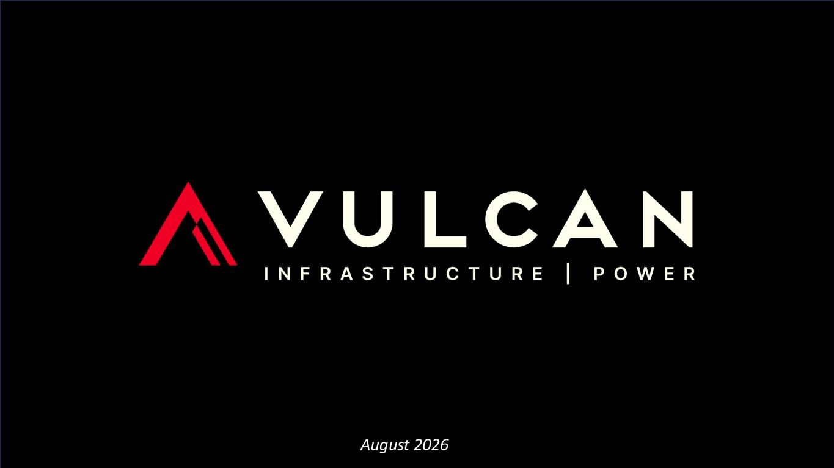

1August 2026

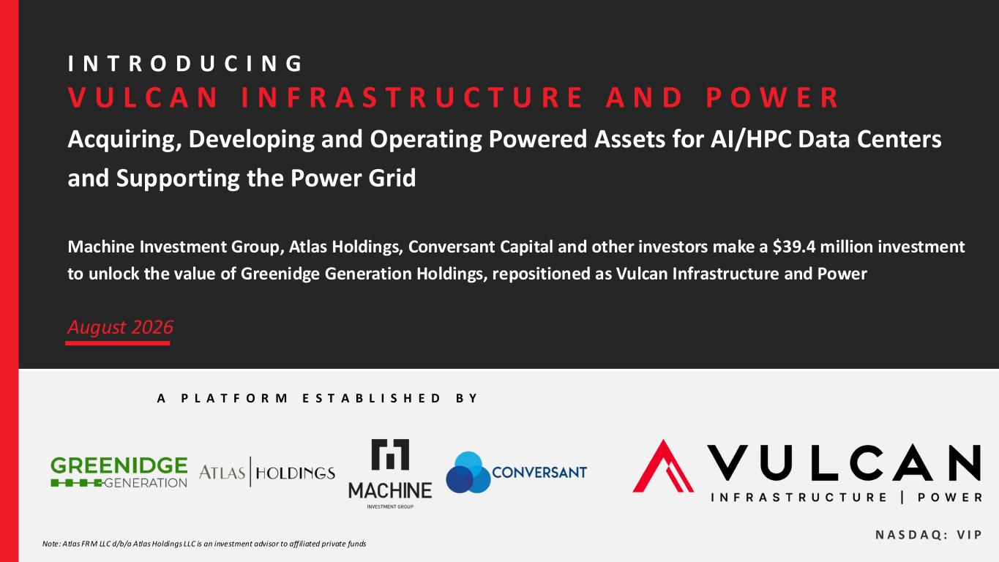
2 Acquiring, Developing and Operating Powered Assets for AI/HPC Data Centers and Supporting the Power Grid Machine Investment Group, Atlas Holdings, Conversant Capital and other investors make a $39.4 million investment to unlock the value of Greenidge Generation Holdings, repositioned as Vulcan Infrastructure and Power A P L A T F O R M E S T A B L I S H E D B Y August 2026 N A S D A Q : V I P Note: Atlas FRM LLC d/b/a Atlas Holdings LLC is an investment advisor to affiliated private funds I N T R O D U C I N G V U L C A N I N F R A S T R U C T U R E A N D P O W E R

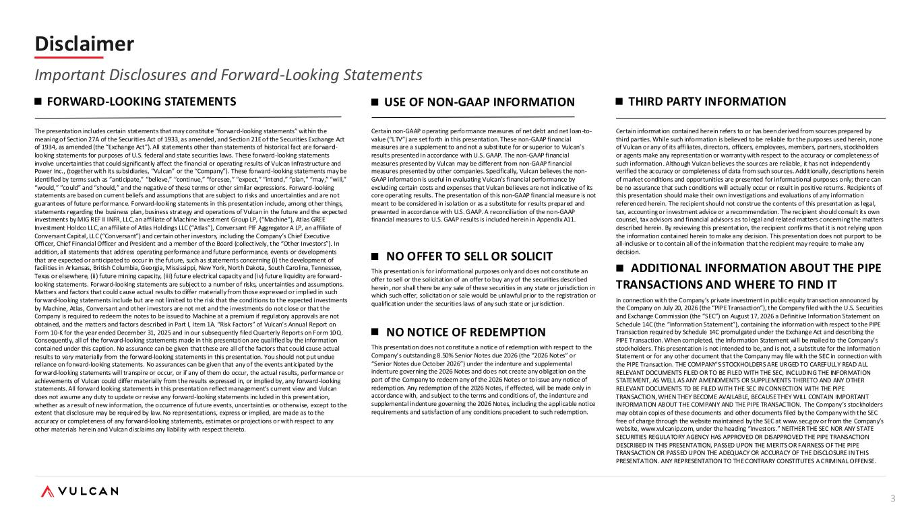
3 Disclaimer Important Disclosures and Forward-Looking Statements FORWARD-LOOKING STATEMENTS The presentation includes certain statements that may constitute “forward-looking statements” within the meaning of Section 27A of the Securities Act of 1933, as amended, and Section 21E of the Securities Exchange Act of 1934, as amended (the “Exchange Act”). All statements other than statements of historical fact are forward- looking statements for purposes of U.S. federal and state securities laws. These forward-looking statements involve uncertainties that could significantly affect the financial or operating results of Vulcan Infrastructure and Power Inc., (together with its subsidiaries, “Vulcan” or the “Company”). These forward-looking statements may be identified by terms such as “anticipate,” “believe,” “continue,” “foresee,” “expect,” “intend,” “plan,” “may,” “will,” “would,” “could” and “should,” and the negative of these terms or other similar expressions. Forward-looking statements are based on current beliefs and assumptions that are subject to risks and uncertainties and are not guarantees of future performance. Forward-looking statements in this presentation include, among other things, statements regarding the business plan, business strategy and operations of Vulcan in the future and the expected investments by MIG REF II INFR, LLC, an affiliate of Machine Investment Group LP, (“Machine”), Atlas GREE Investment Holdco LLC, an affiliate of Atlas Holdings LLC (“Atlas”), Conversant PIF Aggregator A LP, an affiliate of Conversant Capital, LLC (“Conversant”) and certain other investors, including the Company’s Chief Executive Officer, Chief Financial Officer and President and a member of the Board (collectively, the “Other Investors”). In addition, all statements that address operating performance and future performance, events or developments that are expected or anticipated to occur in the future, such as statements concerning (i) the development of facilities in Arkansas, British Columbia, Georgia, Mississippi, New York, North Dakota, South Carolina, Tennessee, Texas or elsewhere, (ii) future mining capacity, (iii) future electrical capacity and (iv) future liquidity are forward- looking statements. Forward-looking statements are subject to a number of risks, uncertainties and assumptions. Matters and factors that could cause actual results to differ materially from those expressed or implied in such forward-looking statements include but are not limited to the risk that the conditions to the expected investments by Machine, Atlas, Conversant and other investors are not met and the investments do not close or that the Company is required to redeem the notes to be issued to Machine at a premium if regulatory approvals are not obtained, and the matters and factors described in Part I, Item 1A. “Risk Factors” of Vulcan’s Annual Report on Form 10-K for the year ended December 31, 2025 and in our subsequently filed Quarterly Reports on Form 10-Q. Consequently, all of the forward-looking statements made in this presentation are qualified by the information contained under this caption. No assurance can be given that these are all of the factors that could cause actual results to vary materially from the forward-looking statements in this presentation. You should not put undue reliance on forward-looking statements. No assurances can be given that any of the events anticipated by the forward-looking statements will transpire or occur, or if any of them do occur, the actual results, performance or achievements of Vulcan could differ materially from the results expressed in, or implied by, any forward-looking statements. All forward looking statements in this presentation reflect management’s current view and Vulcan does not assume any duty to update or revise any forward-looking statements included in this presentation, whether as a result of new information, the occurrence of future events, uncertainties or otherwise, except to the extent that disclosure may be required by law. No representations, express or implied, are made as to the accuracy or completeness of any forward-looking statements, estimates or projections or with respect to any other materials herein and Vulcan disclaims any liability with respect thereto. USE OF NON-GAAP INFORMATION Certain non-GAAP operating performance measures of net debt and net loan-to- value (“LTV”) are set forth in this presentation. These non-GAAP financial measures are a supplement to and not a substitute for or superior to Vulcan’s results presented in accordance with U.S. GAAP. The non-GAAP financial measures presented by Vulcan may be different from non-GAAP financial measures presented by other companies. Specifically, Vulcan believes the non- GAAP information is useful in evaluating Vulcan’s financial performance by excluding certain costs and expenses that Vulcan believes are not indicative of its core operating results. The presentation of this non-GAAP financial measure is not meant to be considered in isolation or as a substitute for results prepared and presented in accordance with U.S. GAAP. A reconciliation of the non-GAAP financial measures to U.S. GAAP results is included herein in Appendix A11. NO OFFER TO SELL OR SOLICIT This presentation is for informational purposes only and does not constitute an offer to sell or the solicitation of an offer to buy any of the securities described herein, nor shall there be any sale of these securities in any state or jurisdiction in which such offer, solicitation or sale would be unlawful prior to the registration or qualification under the securities laws of any such state or jurisdiction. NO NOTICE OF REDEMPTION This presentation does not constitute a notice of redemption with respect to the Company’s outstanding 8.50% Senior Notes due 2026 (the “2026 Notes” or “Senior Notes due October 2026”) under the indenture and supplemental indenture governing the 2026 Notes and does not create any obligation on the part of the Company to redeem any of the 2026 Notes or to issue any notice of redemption. Any redemption of the 2026 Notes, if effected, will be made only in accordance with, and subject to the terms and conditions of, the indenture and supplemental indenture governing the 2026 Notes, including the applicable notice requirements and satisfaction of any conditions precedent to such redemption. THIRD PARTY INFORMATION Certain information contained herein refers to or has been derived from sources prepared by third parties. While such information is believed to be reliable for the purposes used herein, none of Vulcan or any of its affiliates, directors, officers, employees, members, partners, stockholders or agents make any representation or warranty with respect to the accuracy or completeness of such information. Although Vulcan believes the sources are reliable, it has not independently verified the accuracy or completeness of data from such sources. Additionally, descriptions herein of market conditions and opportunities are presented for informational purposes only; there can be no assurance that such conditions will actually occur or result in positive returns. Recipients of this presentation should make their own investigations and evaluations of any information referenced herein. The recipient should not construe the contents of this presentation as legal, tax, accounting or investment advice or a recommendation. The recipient should consult its own counsel, tax advisors and financial advisors as to legal and related matters concerning the matters described herein. By reviewing this presentation, the recipient confirms that it is not relying upon the information contained herein to make any decision. This presentation does not purport to be all-inclusive or to contain all of the information that the recipient may require to make any decision. ADDITIONAL INFORMATION ABOUT THE PIPE TRANSACTIONS AND WHERE TO FIND IT In connection with the Company’s private investment in public equity transaction announced by the Company on July 20, 2026 (the “PIPE Transaction”), the Company filed with the U.S. Securities and Exchange Commission (the “SEC”) on August 17, 2026 a Definitive Information Statement on Schedule 14C (the “Information Statement”), containing the information with respect to the PIPE Transaction required by Schedule 14C promulgated under the Exchange Act and describing the PIPE Transaction. When completed, the Information Statement will be mailed to the Company’s stockholders. This presentation is not intended to be, and is not, a substitute for the Information Statement or for any other document that the Company may file with the SEC in connection with the PIPE Transaction. THE COMPANY’S STOCKHOLDERS ARE URGED TO CAREFULLY READ ALL RELEVANT DOCUMENTS FILED OR TO BE FILED WITH THE SEC, INCLUDING THE INFORMATION STATEMENT, AS WELL AS ANY AMENDMENTS OR SUPPLEMENTS THERETO AND ANY OTHER RELEVANT DOCUMENTS TO BE FILED WITH THE SEC IN CONNECTION WITH THE PIPE TRANSACTION, WHEN THEY BECOME AVAILABLE, BECAUSE THEY WILL CONTAIN IMPORTANT INFORMATION ABOUT THE COMPANY AND THE PIPE TRANSACTION. The Company’s stockholders may obtain copies of these documents and other documents filed by the Company with the SEC free of charge through the website maintained by the SEC at www.sec.gov or from the Company’s website, www.vulcanip.com, under the heading “Investors.” NEITHER THE SEC NOR ANY STATE SECURITIES REGULATORY AGENCY HAS APPROVED OR DISAPPROVED THE PIPE TRANSACTION DESCRIBED IN THIS PRESENTATION, PASSED UPON THE MERITS OR FAIRNESS OF THE PIPE TRANSACTION OR PASSED UPON THE ADEQUACY OR ACCURACY OF THE DISCLOSURE IN THIS PRESENTATION. ANY REPRESENTATION TO THE CONTRARY CONSTITUTES A CRIMINAL OFFENSE.

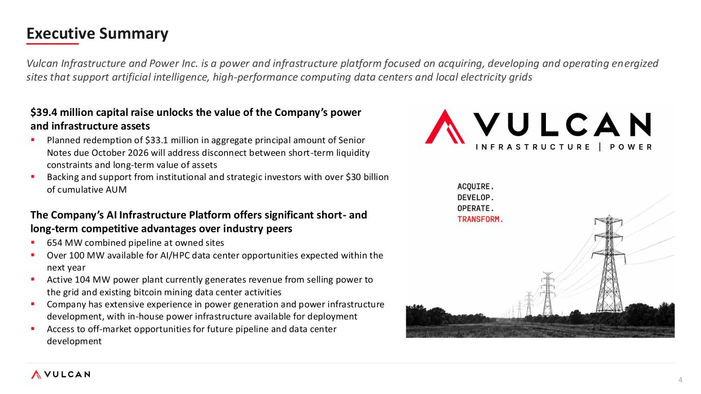
4 Executive Summary Vulcan Infrastructure and Power Inc. is a power and infrastructure platform focused on acquiring, developing and operating energized sites that support artificial intelligence, high-performance computing data centers and local electricity grids $39.4 million capital raise unlocks the value of the Company’s power and infrastructure assets ▪ Planned redemption of $33.1 million in aggregate principal amount of Senior Notes due October 2026 will address disconnect between short-term liquidity constraints and long-term value of assets ▪ Backing and support from institutional and strategic investors with over $30 billion of cumulative AUM The Company’s AI Infrastructure Platform offers significant short- and long-term competitive advantages over industry peers ▪ 654 MW combined pipeline at owned sites ▪ Over 100 MW available for AI/HPC data center opportunities expected within the next year ▪ Active 104 MW power plant currently generates revenue from selling power to the grid and existing bitcoin mining data center activities ▪ Company has extensive experience in power generation and power infrastructure development, with in-house power infrastructure available for deployment ▪ Access to off-market opportunities for future pipeline and data center development

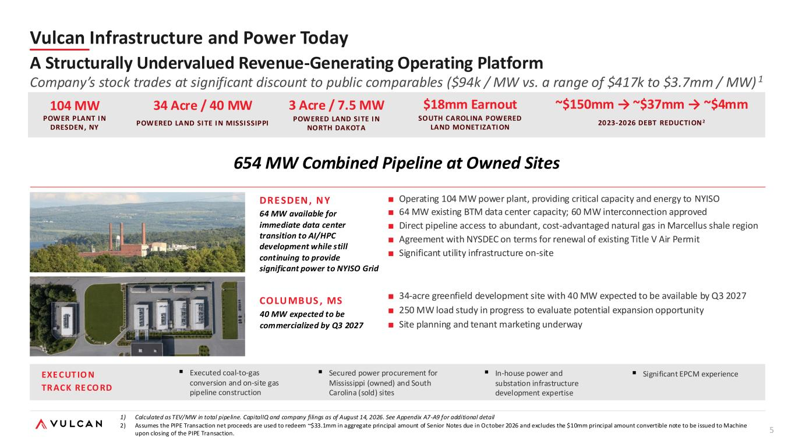
5 654 MW Combined Pipeline at Owned Sites 104 MW POWER PLANT I N DRESDEN, NY ~$150mm → ~$37mm → ~$4mm 2023-2026 DEBT REDUCTI ON 2 $18mm Earnout SOUTH CAROL INA POWERED LAND MONET IZATI ON DRE SDEN , N Y 64 MW available for immediate data center transition to AI/HPC development while still continuing to provide significant power to NYISO Grid ■ Operating 104 MW power plant, providing critical capacity and energy to NYISO ■ 64 MW existing BTM data center capacity; 60 MW interconnection approved ■ Direct pipeline access to abundant, cost-advantaged natural gas in Marcellus shale region ■ Agreement with NYSDEC on terms for renewal of existing Title V Air Permit ■ Significant utility infrastructure on-site COLU MBUS , MS 40 MW expected to be commercialized by Q3 2027 ■ 34-acre greenfield development site with 40 MW expected to be available by Q3 2027 ■ 250 MW load study in progress to evaluate potential expansion opportunity ■ Site planning and tenant marketing underway EXE CUT IO N TR ACK RE CO RD ▪ Executed coal-to-gas conversion and on-site gas pipeline construction ▪ Secured power procurement for Mississippi (owned) and South Carolina (sold) sites ▪ In-house power and substation infrastructure development expertise 34 Acre / 40 MW POWERED LAND SI TE I N MISSI SSIPPI Vulcan Infrastructure and Power Today A Structurally Undervalued Revenue-Generating Operating Platform Company’s stock trades at significant discount to public comparables ($94k / MW vs. a range of $417k to $3.7mm / MW) 1 3 Acre / 7.5 MW POWERED LAND SI TE I N NORTH DAKOT A ▪ Significant EPCM experience 1) Calculated as TEV/MW in total pipeline. CapitalIQ and company filings as of August 14, 2026. See Appendix A7-A9 for additional detail 2) Assumes the PIPE Transaction net proceeds are used to redeem ~$33.1mm in aggregate principal amount of Senior Notes due in October 2026 and excludes the $10mm principal amount convertible note to be issued to Machine upon closing of the PIPE Transaction.

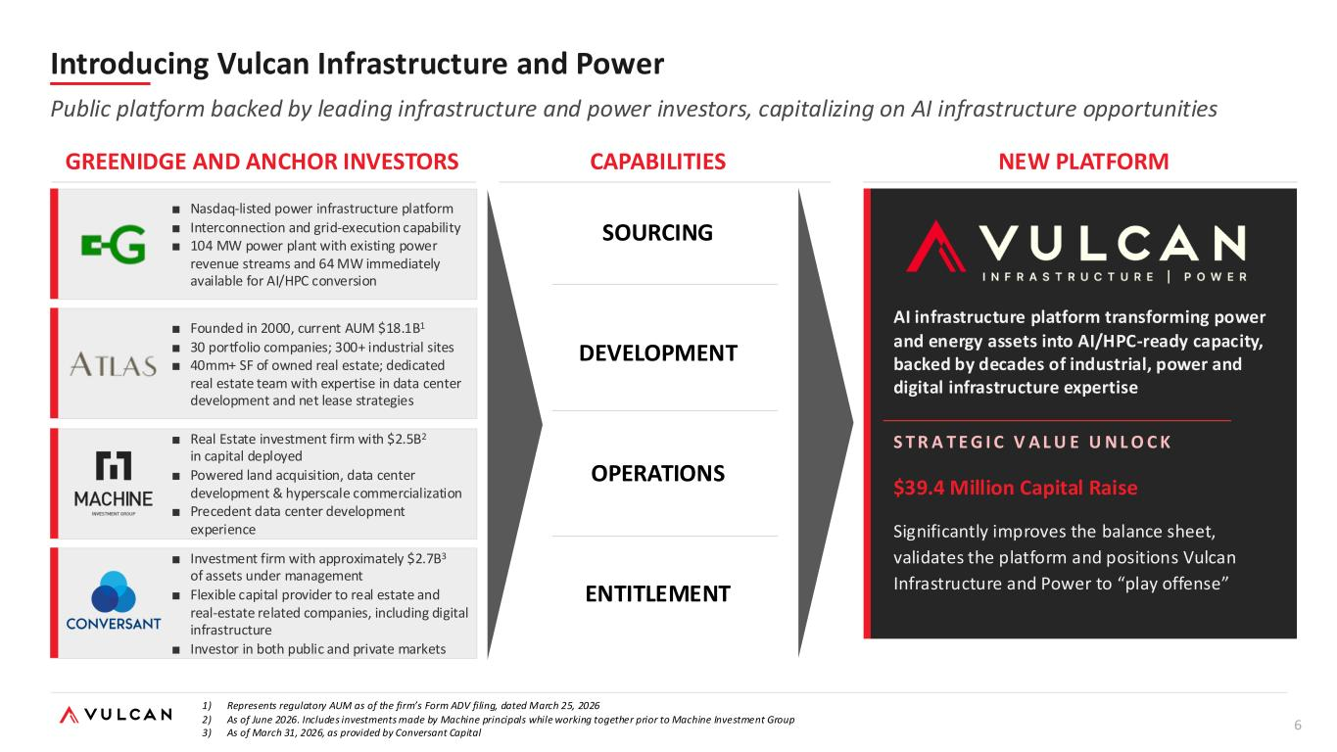
6 1) Represents regulatory AUM as of the firm’s Form ADV filing, dated March 25, 2026 2) As of June 2026. Includes investments made by Machine principals while working together prior to Machine Investment Group 3) As of March 31, 2026, as provided by Conversant Capital ■ Nasdaq-listed power infrastructure platform ■ Interconnection and grid-execution capability ■ 104 MW power plant with existing power revenue streams and 64 MW immediately available for AI/HPC conversion ■ Founded in 2000, current AUM $18.1B1 ■ 30 portfolio companies; 300+ industrial sites ■ 40mm+ SF of owned real estate; dedicated real estate team with expertise in data center development and net lease strategies ■ Real Estate investment firm with $2.5B2 in capital deployed ■ Powered land acquisition, data center development & hyperscale commercialization ■ Precedent data center development experience [VULCAN LOGO] AI infrastructure platform transforming power and energy assets into AI/HPC-ready capacity, backed by decades of industrial, power and digital infrastructure expertise S T R A T E G I C V A L U E U N L O C K $39.4 Million Capital Raise Significantly improves the balance sheet, validates the platform and positions Vulcan Infrastructure and Power to “play offense” GREENIDGE AND ANCHOR INVESTORS CAPABILITIES NEW PLATFORM SOURCING DEVELOPMENT OPERATIONS ENTITLEMENT Introducing Vulcan Infrastructure and Power Public platform backed by leading infrastructure and power investors, capitalizing on AI infrastructure opportunities ■ Investment firm with approximately $2.7B3 of assets under management ■ Flexible capital provider to real estate and real-estate related companies, including digital infrastructure ■ Investor in both public and private markets

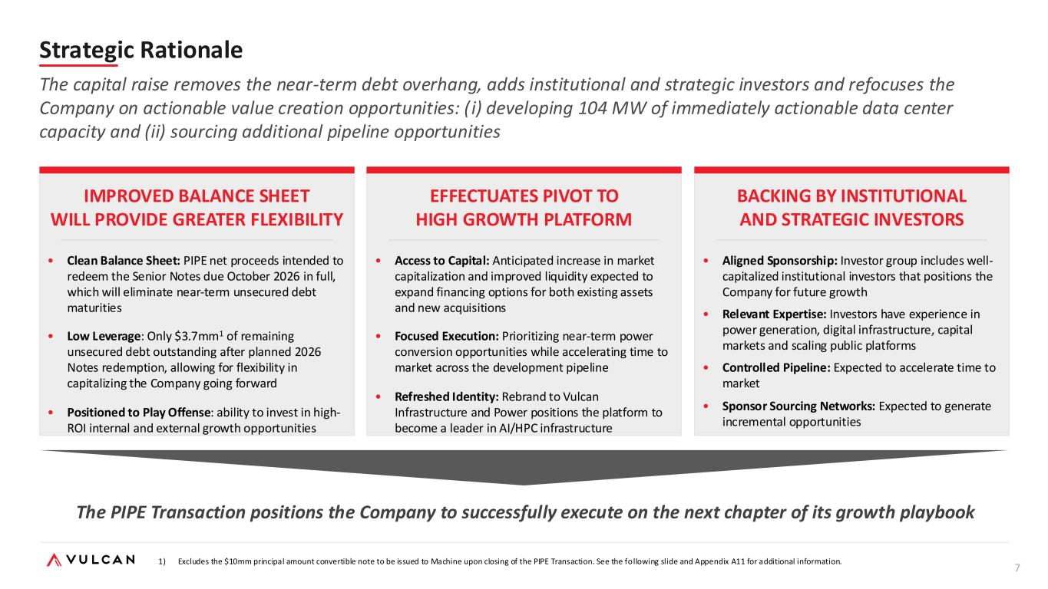
7 Strategic Rationale The PIPE Transaction positions the Company to successfully execute on the next chapter of its growth playbook The capital raise removes the near-term debt overhang, adds institutional and strategic investors and refocuses the Company on actionable value creation opportunities: (i) developing 104 MW of immediately actionable data center capacity and (ii) sourcing additional pipeline opportunities • Clean Balance Sheet: PIPE net proceeds intended to redeem the Senior Notes due October 2026 in full, which will eliminate near-term unsecured debt maturities • Low Leverage: Only $3.7mm1 of remaining unsecured debt outstanding after planned 2026 Notes redemption, allowing for flexibility in capitalizing the Company going forward • Positioned to Play Offense: ability to invest in high- ROI internal and external growth opportunities IMPROVED BALANCE SHEET WILL PROVIDE GREATER FLEXIBILITY EFFECTUATES PIVOT TO HIGH GROWTH PLATFORM BACKING BY INSTITUTIONAL AND STRATEGIC INVESTORS • Access to Capital: Anticipated increase in market capitalization and improved liquidity expected to expand financing options for both existing assets and new acquisitions • Focused Execution: Prioritizing near-term power conversion opportunities while accelerating time to market across the development pipeline • Refreshed Identity: Rebrand to Vulcan Infrastructure and Power positions the platform to become a leader in AI/HPC infrastructure • Aligned Sponsorship: Investor group includes well- capitalized institutional investors that positions the Company for future growth • Relevant Expertise: Investors have experience in power generation, digital infrastructure, capital markets and scaling public platforms • Controlled Pipeline: Expected to accelerate time to market • Sponsor Sourcing Networks: Expected to generate incremental opportunities 1) Excludes the $10mm principal amount convertible note to be issued to Machine upon closing of the PIPE Transaction. See the following slide and Appendix A11 for additional information.

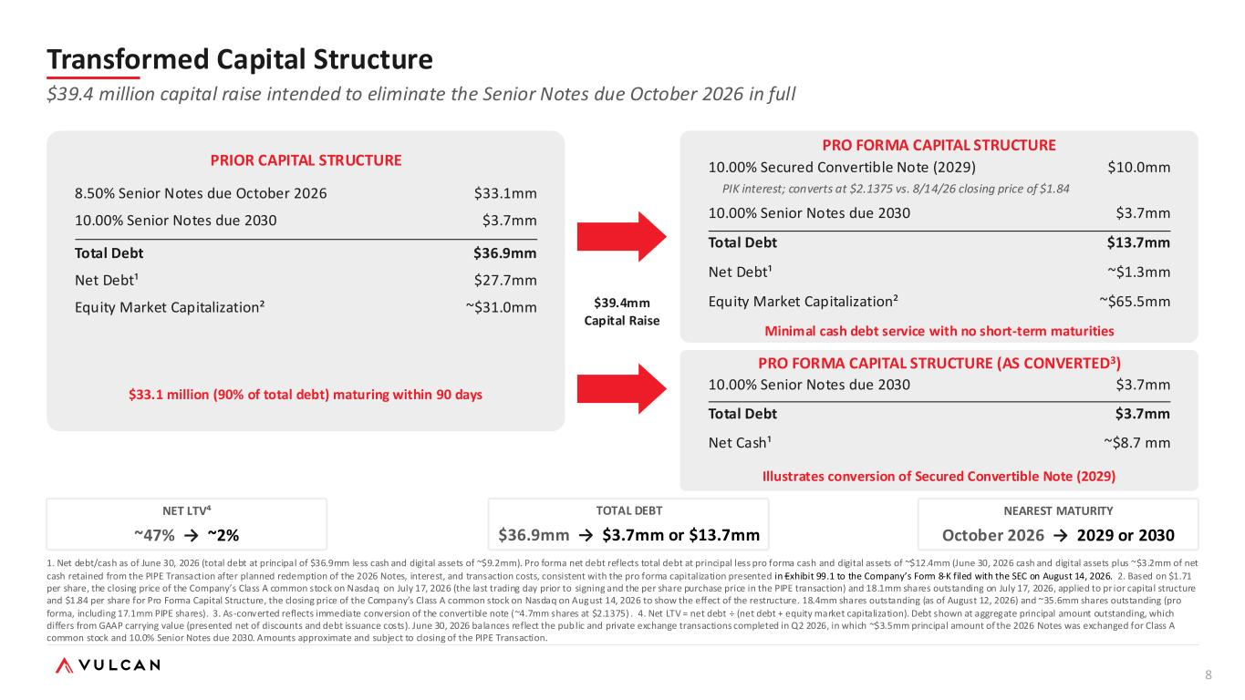
8 Transformed Capital Structure $39.4 million capital raise intended to eliminate the Senior Notes due October 2026 in full PRIOR CAPITAL STRUCTURE 8.50% Senior Notes due October 2026 $33.1mm 10.00% Senior Notes due 2030 $3.7mm Total Debt $36.9mm Net Debt¹ $27.7mm Equity Market Capitalization² ~$31.0mm $33.1 million (90% of total debt) maturing within 90 days PRO FORMA CAPITAL STRUCTURE (AS CONVERTED3) 10.00% Senior Notes due 2030 $3.7mm Total Debt $3.7mm Net Cash¹ ~$8.7 mm $39.4mm Capital Raise NET LTV⁴ ~47% → ~2% TOTAL DEBT $36.9mm → $3.7mm or $13.7mm NEAREST MATURITY October 2026 → 2029 or 2030 1. Net debt/cash as of June 30, 2026 (total debt at principal of $36.9mm less cash and digital assets of ~$9.2mm). Pro forma net debt reflects total debt at principal less pro forma cash and digital assets of ~$12.4mm (June 30, 2026 cash and digital assets plus ~$3.2mm of net cash retained from the PIPE Transaction after planned redemption of the 2026 Notes, interest, and transaction costs, consistent with the pro forma capitalization presented in Exhibit 99.1 to the Company’s Form 8-K filed with the SEC on August 14, 2026. 2. Based on $1.71 per share, the closing price of the Company’s Class A common stock on Nasdaq on July 17, 2026 (the last trading day prior to signing and the per share purchase price in the PIPE transaction) and 18.1mm shares outstanding on July 17, 2026, applied to pr ior capital structure and $1.84 per share for Pro Forma Capital Structure, the closing price of the Company’s Class A common stock on Nasdaq on August 14, 2026 to show the effect of the restructure. 18.4mm shares outstanding (as of August 12, 2026) and ~35.6mm shares outstanding (pro forma, including 17.1mm PIPE shares). 3. As-converted reflects immediate conversion of the convertible note (~4.7mm shares at $2.1375) . 4. Net LTV = net debt ÷ (net debt + equity market capitalization). Debt shown at aggregate principal amount outstanding, which differs from GAAP carrying value (presented net of discounts and debt issuance costs). June 30, 2026 balances reflect the public and private exchange transactions completed in Q2 2026, in which ~$3.5mm principal amount of the 2026 Notes was exchanged for Class A common stock and 10.0% Senior Notes due 2030. Amounts approximate and subject to closing of the PIPE Transaction. Illustrates conversion of Secured Convertible Note (2029) PRO FORMA CAPITAL STRUCTURE 10.00% Secured Convertible Note (2029) $10.0mm PIK interest; converts at $2.1375 vs. 8/14/26 closing price of $1.84 10.00% Senior Notes due 2030 $3.7mm Total Debt $13.7mm Net Debt¹ ~$1.3mm Equity Market Capitalization² ~$65.5mm Minimal cash debt service with no short-term maturities

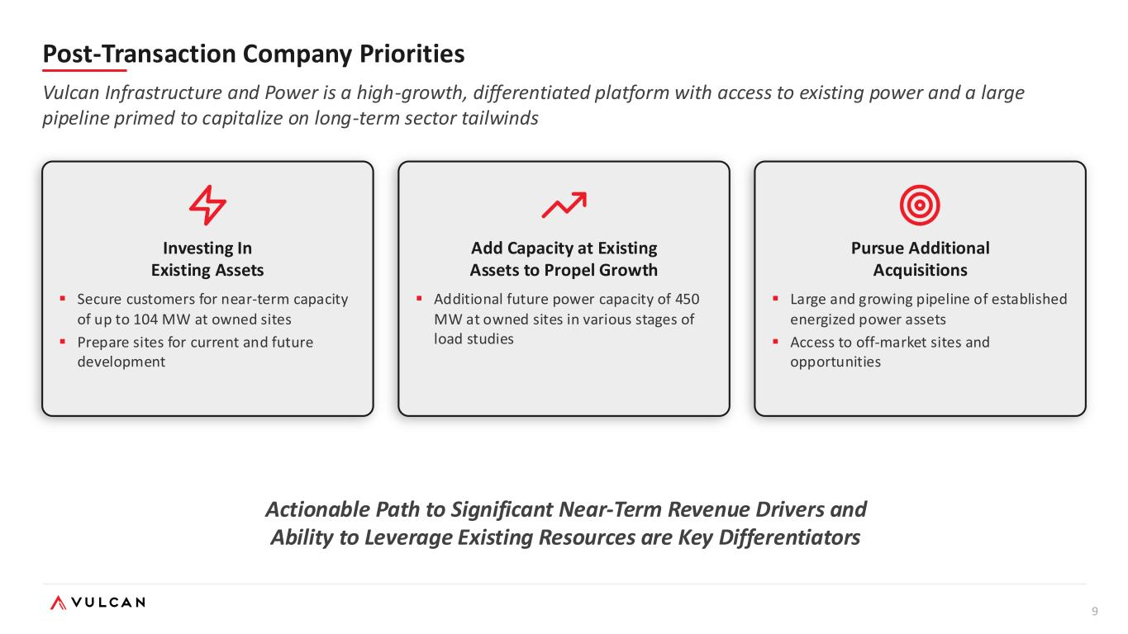
9 Post-Transaction Company Priorities Vulcan Infrastructure and Power is a high-growth, differentiated platform with access to existing power and a large pipeline primed to capitalize on long-term sector tailwinds Actionable Path to Significant Near-Term Revenue Drivers and Ability to Leverage Existing Resources are Key Differentiators Investing In Existing Assets ▪ Secure customers for near-term capacity of up to 104 MW at owned sites ▪ Prepare sites for current and future development Add Capacity at Existing Assets to Propel Growth ▪ Additional future power capacity of 450 MW at owned sites in various stages of load studies Pursue Additional Acquisitions ▪ Large and growing pipeline of established energized power assets ▪ Access to off-market sites and opportunities

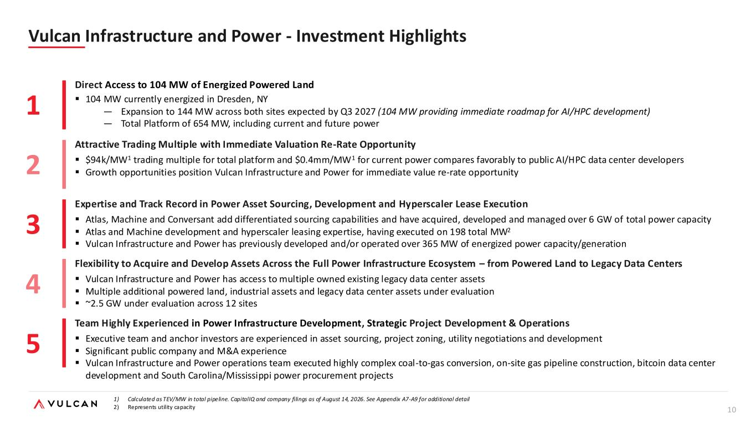
10 1 Direct Access to 104 MW of Energized Powered Land ▪ 104 MW currently energized in Dresden, NY — Expansion to 144 MW across both sites expected by Q3 2027 (104 MW providing immediate roadmap for AI/HPC development) — Total Platform of 654 MW, including current and future power 2 Expertise and Track Record in Power Asset Sourcing, Development and Hyperscaler Lease Execution ▪ Atlas, Machine and Conversant add differentiated sourcing capabilities and have acquired, developed and managed over 6 GW of total power capacity ▪ Atlas and Machine development and hyperscaler leasing expertise, having executed on 198 total MW2 ▪ Vulcan Infrastructure and Power has previously developed and/or operated over 365 MW of energized power capacity/generation 3 Attractive Trading Multiple with Immediate Valuation Re-Rate Opportunity ▪ $94k/MW1 trading multiple for total platform and $0.4mm/MW1 for current power compares favorably to public AI/HPC data center developers ▪ Growth opportunities position Vulcan Infrastructure and Power for immediate value re-rate opportunity 4 Flexibility to Acquire and Develop Assets Across the Full Power Infrastructure Ecosystem – from Powered Land to Legacy Data Centers ▪ Vulcan Infrastructure and Power has access to multiple owned existing legacy data center assets ▪ Multiple additional powered land, industrial assets and legacy data center assets under evaluation ▪ ~2.5 GW under evaluation across 12 sites 5 Team Highly Experienced in Power Infrastructure Development, Strategic Project Development & Operations ▪ Executive team and anchor investors are experienced in asset sourcing, project zoning, utility negotiations and development ▪ Significant public company and M&A experience ▪ Vulcan Infrastructure and Power operations team executed highly complex coal-to-gas conversion, on-site gas pipeline construction, bitcoin data center development and South Carolina/Mississippi power procurement projects Vulcan Infrastructure and Power - Investment Highlights 1) Calculated as TEV/MW in total pipeline. CapitalIQ and company filings as of August 14, 2026. See Appendix A7-A9 for additional detail 2) Represents utility capacity

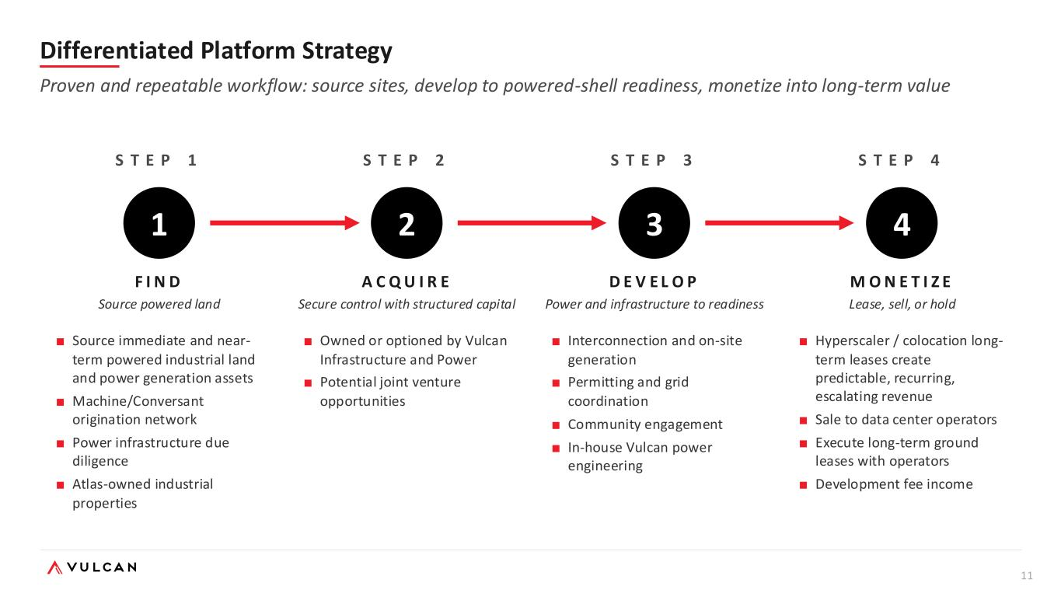
11 S T E P 1 1 F I N D Source powered land ■ Source immediate and near- term powered industrial land and power generation assets ■ Machine/Conversant origination network ■ Power infrastructure due diligence ■ Atlas-owned industrial properties S T E P 2 2 A C Q U I R E Secure control with structured capital ■ Owned or optioned by Vulcan Infrastructure and Power ■ Potential joint venture opportunities S T E P 3 3 D E V E L O P Power and infrastructure to readiness ■ Interconnection and on-site generation ■ Permitting and grid coordination ■ Community engagement ■ In-house Vulcan power engineering S T E P 4 4 M O N E T I Z E Lease, sell, or hold ■ Hyperscaler / colocation long- term leases create predictable, recurring, escalating revenue ■ Sale to data center operators ■ Execute long-term ground leases with operators ■ Development fee income Differentiated Platform Strategy Proven and repeatable workflow: source sites, develop to powered-shell readiness, monetize into long-term value

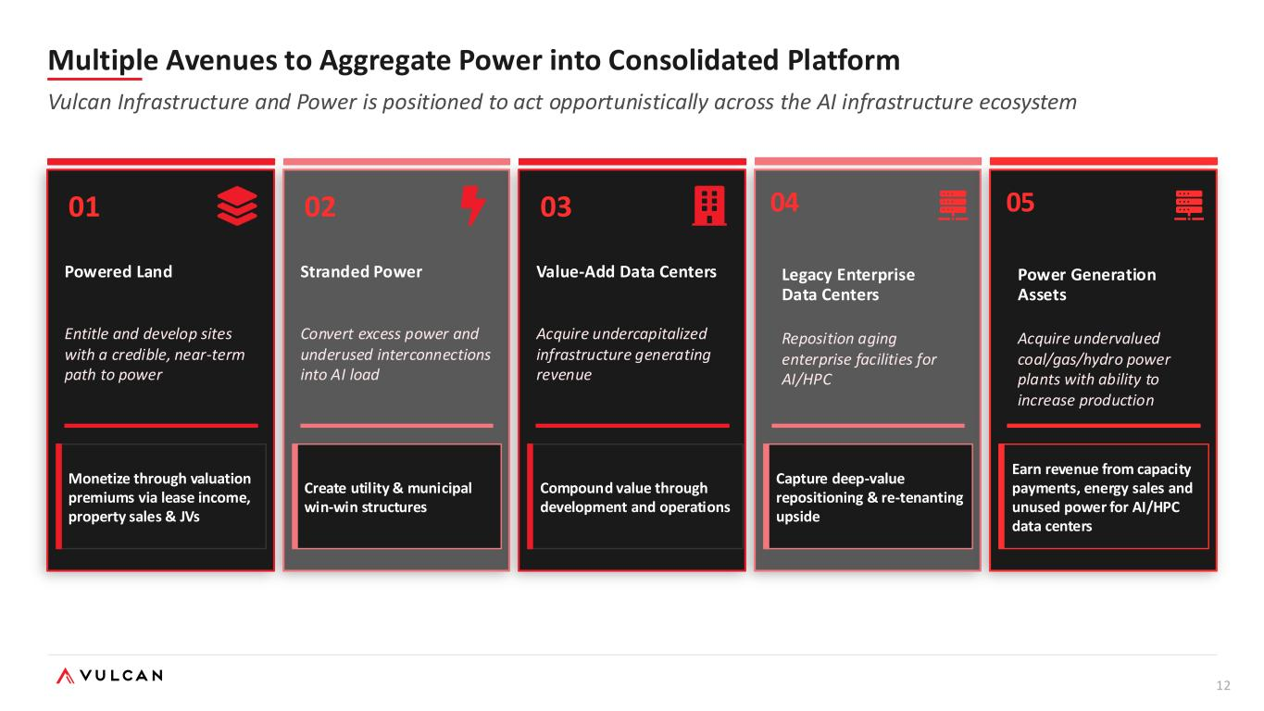
12 01 Powered Land Entitle and develop sites with a credible, near-term path to power Monetize through valuation premiums via lease income, property sales & JVs 02 Stranded Power Convert excess power and underused interconnections into AI load Create utility & municipal win-win structures 03 Value-Add Data Centers Acquire undercapitalized infrastructure generating revenue Compound value through development and operations 04 Legacy Enterprise Data Centers Reposition aging enterprise facilities for AI/HPC Capture deep-value repositioning & re-tenanting upside Multiple Avenues to Aggregate Power into Consolidated Platform Vulcan Infrastructure and Power is positioned to act opportunistically across the AI infrastructure ecosystem 05 Power Generation Assets Acquire undervalued coal/gas/hydro power plants with ability to increase production Earn revenue from capacity payments, energy sales and unused power for AI/HPC data centers

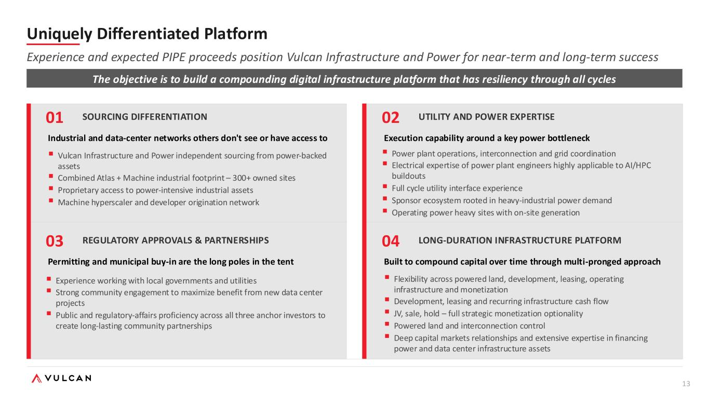
13 01 SOURCING DIFFERENTIATION Industrial and data-center networks others don't see or have access to 02 UTILITY AND POWER EXPERTISE Execution capability around a key power bottleneck ▪ Power plant operations, interconnection and grid coordination ▪ Electrical expertise of power plant engineers highly applicable to AI/HPC buildouts ▪ Full cycle utility interface experience ▪ Sponsor ecosystem rooted in heavy-industrial power demand ▪ Operating power heavy sites with on-site generation 03 REGULATORY APPROVALS & PARTNERSHIPS Permitting and municipal buy-in are the long poles in the tent ▪ Experience working with local governments and utilities ▪ Strong community engagement to maximize benefit from new data center projects ▪ Public and regulatory-affairs proficiency across all three anchor investors to create long-lasting community partnerships 04 LONG-DURATION INFRASTRUCTURE PLATFORM Built to compound capital over time through multi-pronged approach ▪ Vulcan Infrastructure and Power independent sourcing from power-backed assets ▪ Combined Atlas + Machine industrial footprint – 300+ owned sites ▪ Proprietary access to power-intensive industrial assets ▪ Machine hyperscaler and developer origination network ▪ Flexibility across powered land, development, leasing, operating infrastructure and monetization ▪ Development, leasing and recurring infrastructure cash flow ▪ JV, sale, hold – full strategic monetization optionality ▪ Powered land and interconnection control ▪ Deep capital markets relationships and extensive expertise in financing power and data center infrastructure assets The objective is to build a compounding digital infrastructure platform that has resiliency through all cycles Uniquely Differentiated Platform Experience and expected PIPE proceeds position Vulcan Infrastructure and Power for near-term and long-term success

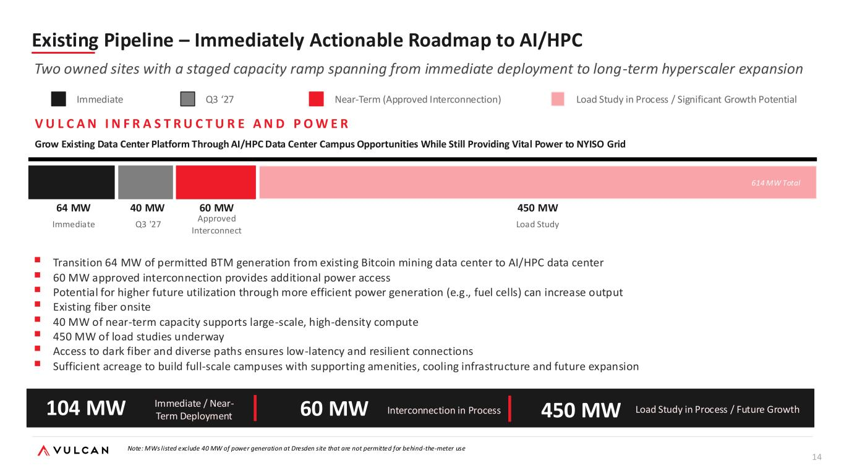
14 Existing Pipeline – Immediately Actionable Roadmap to AI/HPC Two owned sites with a staged capacity ramp spanning from immediate deployment to long-term hyperscaler expansion Immediate Near-Term (Approved Interconnection) Load Study in Process / Significant Growth Potential V U L C A N I N F R A S T R U C T U R E A N D P O W E R Grow Existing Data Center Platform Through AI/HPC Data Center Campus Opportunities While Still Providing Vital Power to NYISO Grid 64 MW Immediate 60 MW Approved Interconnect ▪ Transition 64 MW of permitted BTM generation from existing Bitcoin mining data center to AI/HPC data center ▪ 60 MW approved interconnection provides additional power access ▪ Potential for higher future utilization through more efficient power generation (e.g., fuel cells) can increase output ▪ Existing fiber onsite ▪ 40 MW of near-term capacity supports large-scale, high-density compute ▪ 450 MW of load studies underway ▪ Access to dark fiber and diverse paths ensures low-latency and resilient connections ▪ Sufficient acreage to build full-scale campuses with supporting amenities, cooling infrastructure and future expansion 40 MW Q3 '27 450 MW Load Study 614 MW Total 104 MW Immediate / Near- Term Deployment 450 MW Load Study in Process / Future Growth60 MW Interconnection in Process Note: MWs listed exclude 40 MW of power generation at Dresden site that are not permitted for behind-the-meter use Q3 ‘27

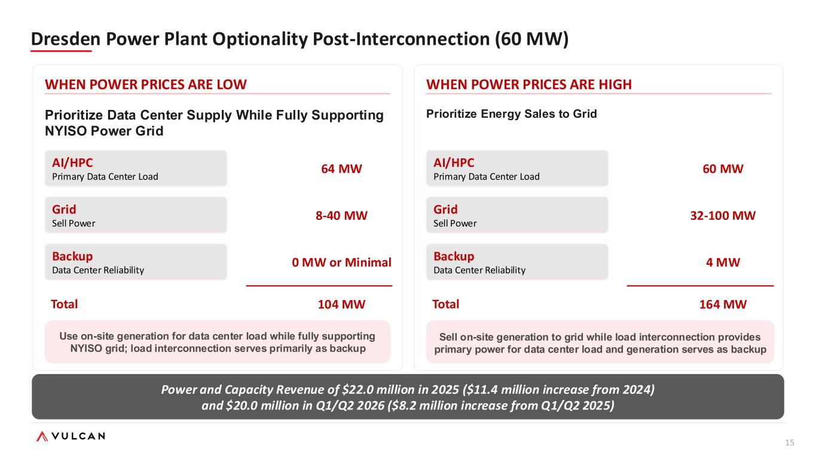
15 Dresden Power Plant Optionality Post-Interconnection (60 MW) WHEN POWER PRICES ARE LOW Prioritize Data Center Supply While Fully Supporting NYISO Power Grid Use on-site generation for data center load while fully supporting NYISO grid; load interconnection serves primarily as backup WHEN POWER PRICES ARE HIGH Sell on-site generation to grid while load interconnection provides primary power for data center load and generation serves as backup Power and Capacity Revenue of $22.0 million in 2025 ($11.4 million increase from 2024) and $20.0 million in Q1/Q2 2026 ($8.2 million increase from Q1/Q2 2025) Prioritize Energy Sales to Grid AI/HPC Primary Data Center Load Grid Sell Power Backup Data Center Reliability 64 MW 8-40 MW 0 MW or Minimal 104 MWTotal AI/HPC Primary Data Center Load Grid Sell Power Backup Data Center Reliability 60 MW 32-100 MW 4 MW 164 MWTotal

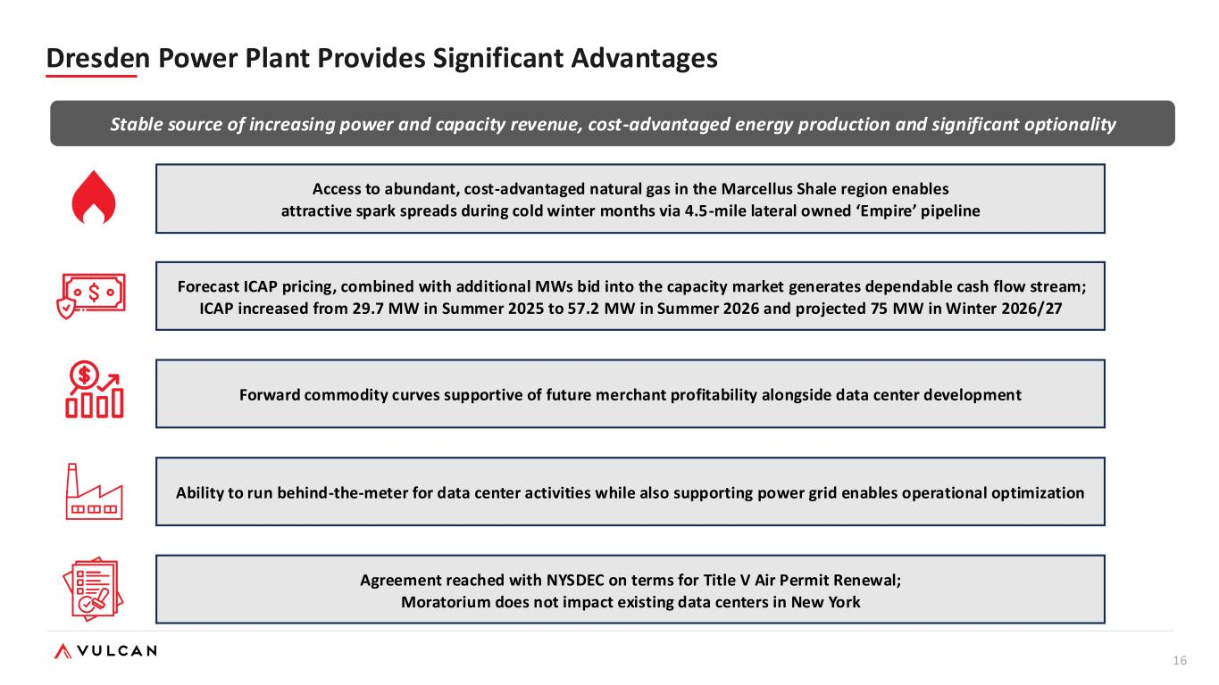
16 Access to abundant, cost-advantaged natural gas in the Marcellus Shale region enables attractive spark spreads during cold winter months via 4.5-mile lateral owned ‘Empire’ pipeline Forecast ICAP pricing, combined with additional MWs bid into the capacity market generates dependable cash flow stream; ICAP increased from 29.7 MW in Summer 2025 to 57.2 MW in Summer 2026 and projected 75 MW in Winter 2026/27 Forward commodity curves supportive of future merchant profitability alongside data center development Ability to run behind-the-meter for data center activities while also supporting power grid enables operational optimization Agreement reached with NYSDEC on terms for Title V Air Permit Renewal; Moratorium does not impact existing data centers in New York Stable source of increasing power and capacity revenue, cost-advantaged energy production and significant optionality Dresden Power Plant Provides Significant Advantages

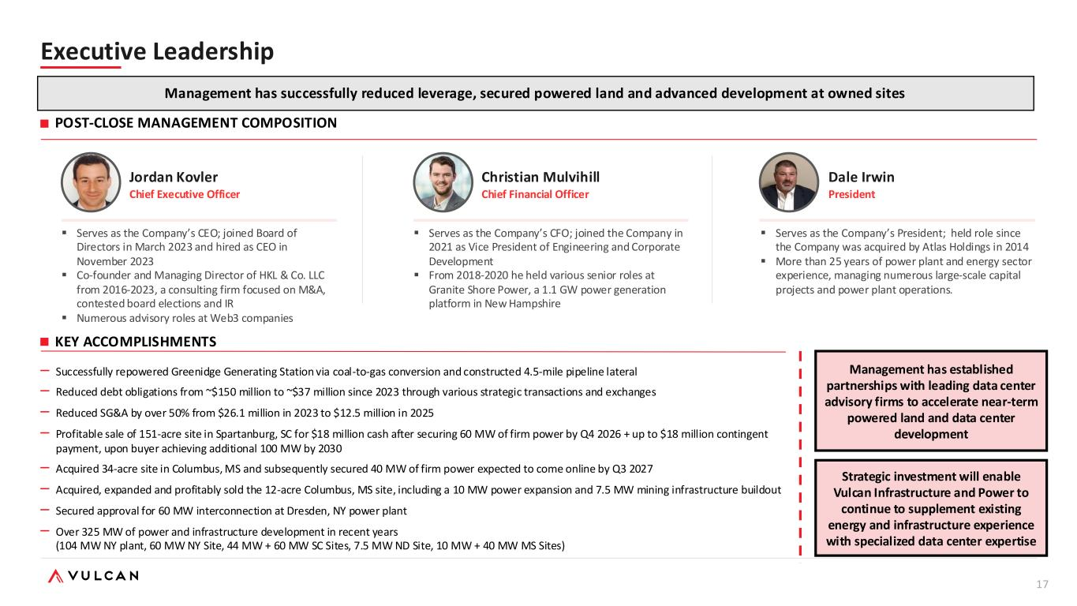
17 Christian Mulvihill Chief Financial Officer ▪ Serves as the Company’s CFO; joined the Company in 2021 as Vice President of Engineering and Corporate Development ▪ From 2018-2020 he held various senior roles at Granite Shore Power, a 1.1 GW power generation platform in New Hampshire Dale Irwin President ▪ Serves as the Company’s President; held role since the Company was acquired by Atlas Holdings in 2014 ▪ More than 25 years of power plant and energy sector experience, managing numerous large-scale capital projects and power plant operations. KEY ACCOMPLISHMENTS Jordan Kovler Chief Executive Officer ▪ Serves as the Company’s CEO; joined Board of Directors in March 2023 and hired as CEO in November 2023 ▪ Co-founder and Managing Director of HKL & Co. LLC from 2016-2023, a consulting firm focused on M&A, contested board elections and IR ▪ Numerous advisory roles at Web3 companies POST-CLOSE MANAGEMENT COMPOSITION Executive Leadership – Successfully repowered Greenidge Generating Station via coal-to-gas conversion and constructed 4.5-mile pipeline lateral – Reduced debt obligations from ~$150 million to ~$37 million since 2023 through various strategic transactions and exchanges – Reduced SG&A by over 50% from $26.1 million in 2023 to $12.5 million in 2025 – Profitable sale of 151-acre site in Spartanburg, SC for $18 million cash after securing 60 MW of firm power by Q4 2026 + up to $18 million contingent payment, upon buyer achieving additional 100 MW by 2030 – Acquired 34-acre site in Columbus, MS and subsequently secured 40 MW of firm power expected to come online by Q3 2027 – Acquired, expanded and profitably sold the 12-acre Columbus, MS site, including a 10 MW power expansion and 7.5 MW mining infrastructure buildout – Secured approval for 60 MW interconnection at Dresden, NY power plant – Over 325 MW of power and infrastructure development in recent years (104 MW NY plant, 60 MW NY Site, 44 MW + 60 MW SC Sites, 7.5 MW ND Site, 10 MW + 40 MW MS Sites) Management has established partnerships with leading data center advisory firms to accelerate near-term powered land and data center development Management has successfully reduced leverage, secured powered land and advanced development at owned sites Strategic investment will enable Vulcan Infrastructure and Power to continue to supplement existing energy and infrastructure experience with specialized data center expertise

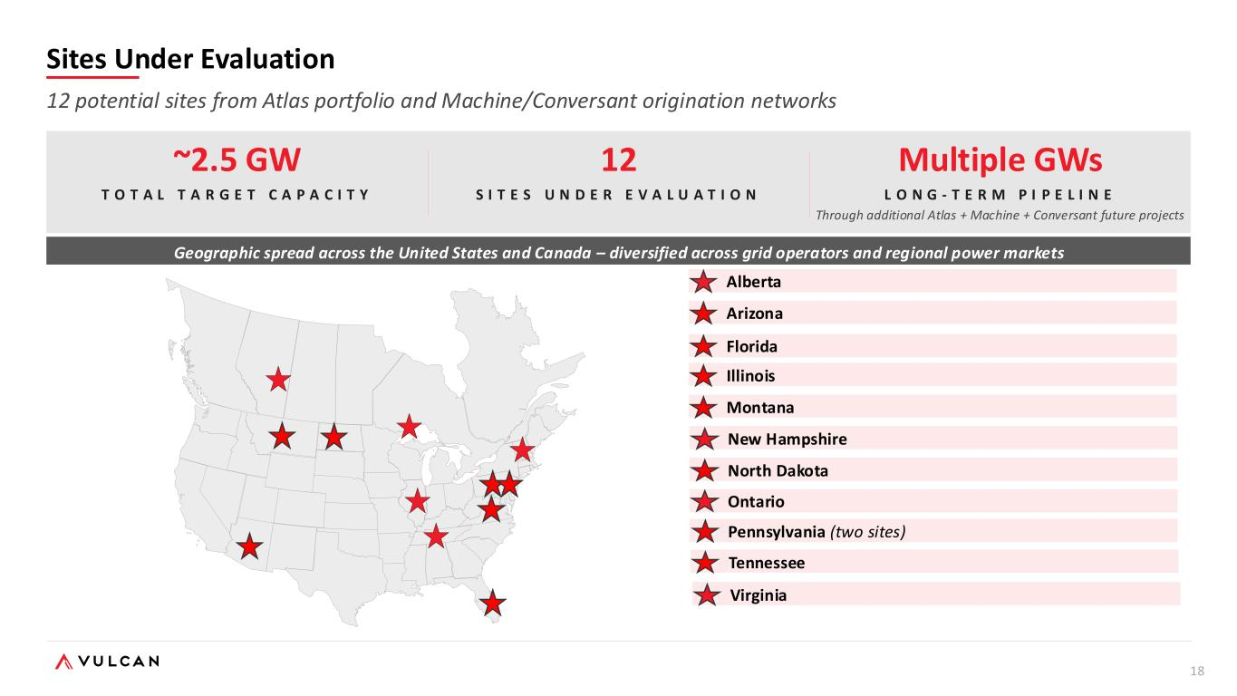
18 ~2.5 GW T O T A L T A R G E T C A P A C I T Y 12 S I T E S U N D E R E V A L U A T I O N Multiple GWs L O N G - T E R M P I P E L I N E Through additional Atlas + Machine + Conversant future projects Geographic spread across the United States and Canada – diversified across grid operators and regional power markets Alberta Arizona Florida Illinois Montana Sites Under Evaluation 12 potential sites from Atlas portfolio and Machine/Conversant origination networks New Hampshire North Dakota Ontario Pennsylvania (two sites) Tennessee Virginia

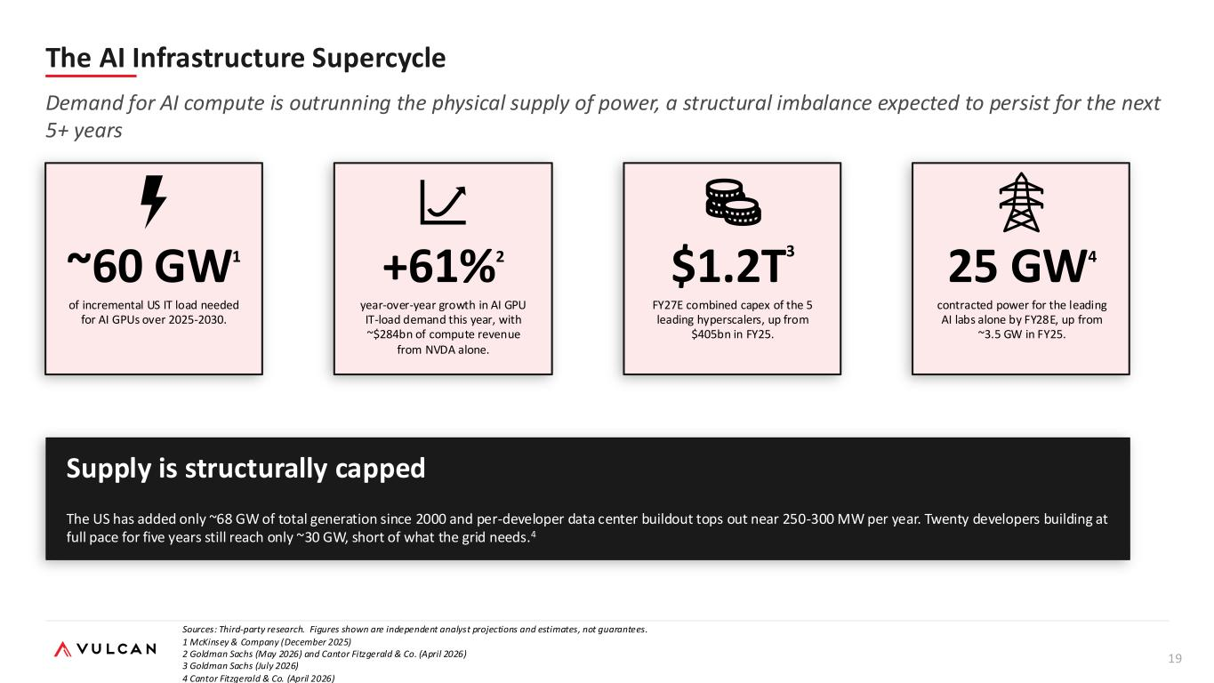
19 The AI Infrastructure Supercycle Demand for AI compute is outrunning the physical supply of power, a structural imbalance expected to persist for the next 5+ years Sources: Third-party research. Figures shown are independent analyst projections and estimates, not guarantees. 1 McKinsey & Company (December 2025) 2 Goldman Sachs (May 2026) and Cantor Fitzgerald & Co. (April 2026) 3 Goldman Sachs (July 2026) 4 Cantor Fitzgerald & Co. (April 2026) of incremental US IT load needed for AI GPUs over 2025-2030. ~60 GW1 year-over-year growth in AI GPU IT-load demand this year, with ~$284bn of compute revenue from NVDA alone. +61%2 FY27E combined capex of the 5 leading hyperscalers, up from $405bn in FY25. $1.2T 3 contracted power for the leading AI labs alone by FY28E, up from ~3.5 GW in FY25. 25 GW4 Supply is structurally capped The US has added only ~68 GW of total generation since 2000 and per-developer data center buildout tops out near 250-300 MW per year. Twenty developers building at full pace for five years still reach only ~30 GW, short of what the grid needs.4


20 A P P E N D I X

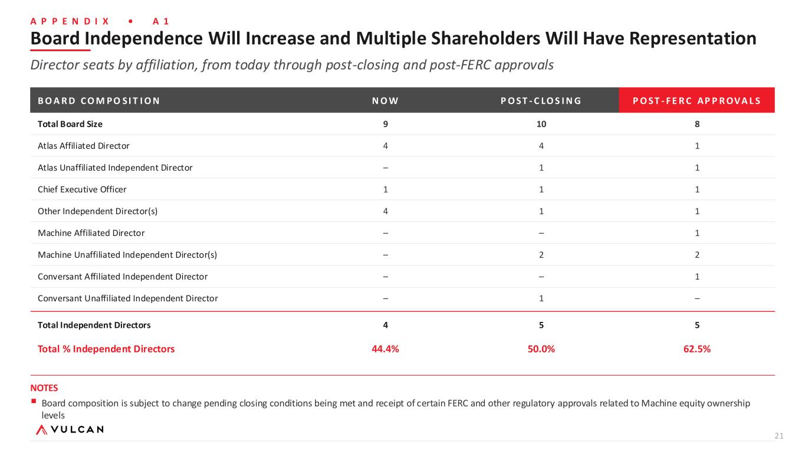
21 A P P E N D I X • A 1 Board Independence Will Increase and Multiple Shareholders Will Have Representation Director seats by affiliation, from today through post-closing and post-FERC approvals B O A R D C O M P O S I T I O N N O W P O S T - C LO S I N G P O S T - F E R C AP P R OV A L S Total Board Size 9 10 8 Atlas Affiliated Director 4 4 1 Atlas Unaffiliated Independent Director – 1 1 Chief Executive Officer 1 1 1 Other Independent Director(s) 4 1 1 Machine Affiliated Director – – 1 Machine Unaffiliated Independent Director(s) – 2 2 Conversant Affiliated Independent Director – – 1 Conversant Unaffiliated Independent Director – 1 – Total Independent Directors 4 5 5 Total % Independent Directors 44.4% 50.0% 62.5% NOTES ▪ Board composition is subject to change pending closing conditions being met and receipt of certain FERC and other regulatory approvals related to Machine equity ownership levels

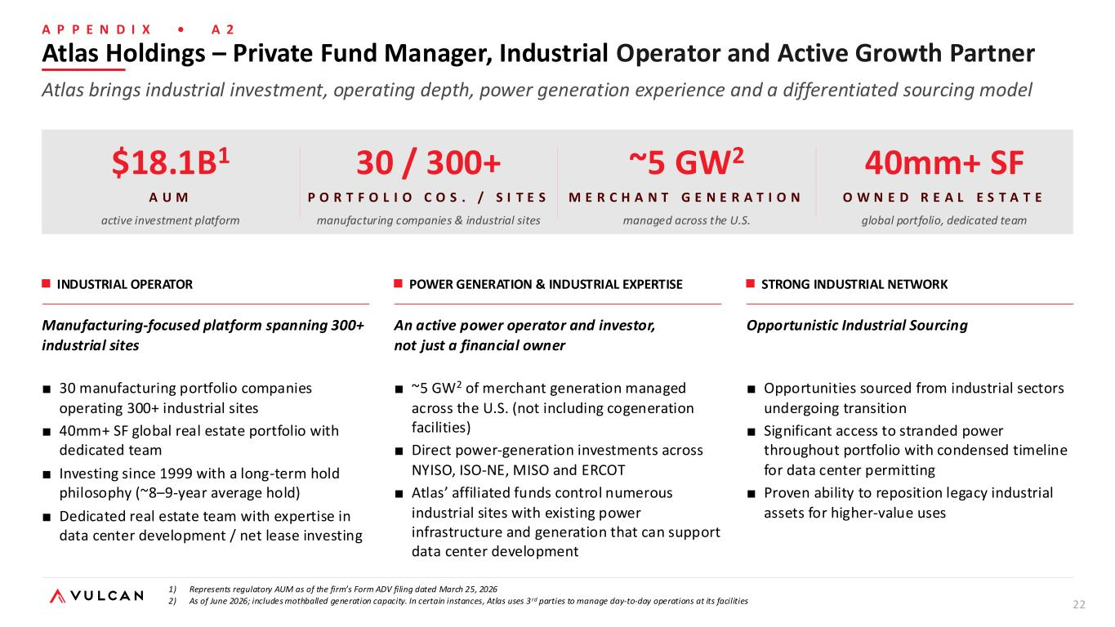
22 A P P E N D I X • A 2 $18.1B1 A U M active investment platform 30 / 300+ P O R T F O L I O C O S . / S I T E S manufacturing companies & industrial sites ~5 GW2 M E R C H A N T G E N E R A T I O N managed across the U.S. 40mm+ SF O W N E D R E A L E S T A T E global portfolio, dedicated team INDUSTRIAL OPERATOR Manufacturing-focused platform spanning 300+ industrial sites ■ 30 manufacturing portfolio companies operating 300+ industrial sites ■ 40mm+ SF global real estate portfolio with dedicated team ■ Investing since 1999 with a long-term hold philosophy (~8–9-year average hold) ■ Dedicated real estate team with expertise in data center development / net lease investing POWER GENERATION & INDUSTRIAL EXPERTISE An active power operator and investor, not just a financial owner ■ ~5 GW2 of merchant generation managed across the U.S. (not including cogeneration facilities) ■ Direct power-generation investments across NYISO, ISO-NE, MISO and ERCOT ■ Atlas’ affiliated funds control numerous industrial sites with existing power infrastructure and generation that can support data center development STRONG INDUSTRIAL NETWORK Opportunistic Industrial Sourcing ■ Opportunities sourced from industrial sectors undergoing transition ■ Significant access to stranded power throughout portfolio with condensed timeline for data center permitting ■ Proven ability to reposition legacy industrial assets for higher-value uses Atlas Holdings – Private Fund Manager, Industrial Operator and Active Growth Partner Atlas brings industrial investment, operating depth, power generation experience and a differentiated sourcing model 1) Represents regulatory AUM as of the firm’s Form ADV filing dated March 25, 2026 2) As of June 2026; includes mothballed generation capacity. In certain instances, Atlas uses 3 rd parties to manage day-to-day operations at its facilities

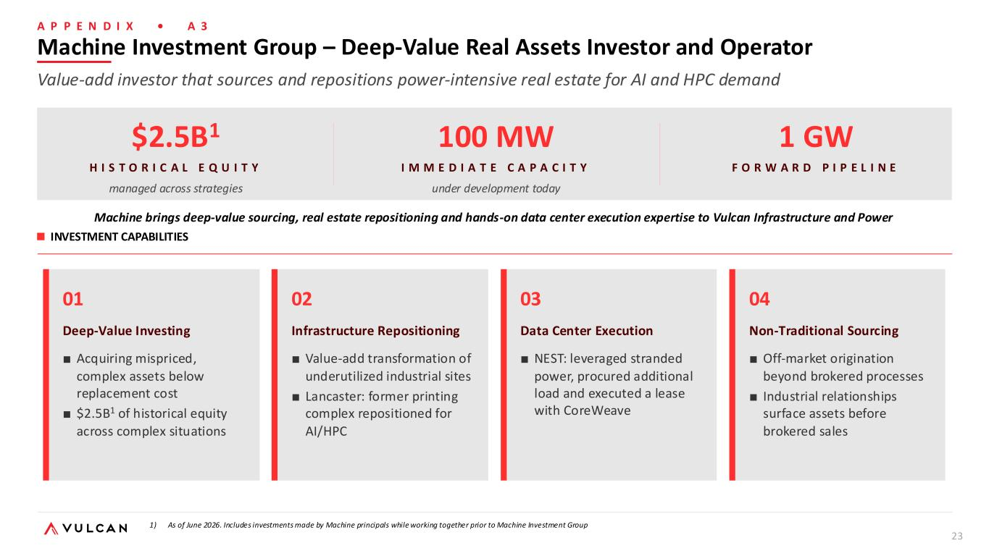
23 A P P E N D I X • A 3 $2.5B1 H I S T O R I C A L E Q U I T Y managed across strategies 100 MW I M M E D I A T E C A P A C I T Y under development today 1 GW F O R W A R D P I P E L I N E INVESTMENT CAPABILITIES Machine brings deep-value sourcing, real estate repositioning and hands-on data center execution expertise to Vulcan Infrastructure and Power 01 Deep-Value Investing ■ Acquiring mispriced, complex assets below replacement cost ■ $2.5B1 of historical equity across complex situations 02 Infrastructure Repositioning ■ Value-add transformation of underutilized industrial sites ■ Lancaster: former printing complex repositioned for AI/HPC 03 Data Center Execution ■ NEST: leveraged stranded power, procured additional load and executed a lease with CoreWeave 04 Non-Traditional Sourcing ■ Off-market origination beyond brokered processes ■ Industrial relationships surface assets before brokered sales Machine Investment Group – Deep-Value Real Assets Investor and Operator Value-add investor that sources and repositions power-intensive real estate for AI and HPC demand 1) As of June 2026. Includes investments made by Machine principals while working together prior to Machine Investment Group

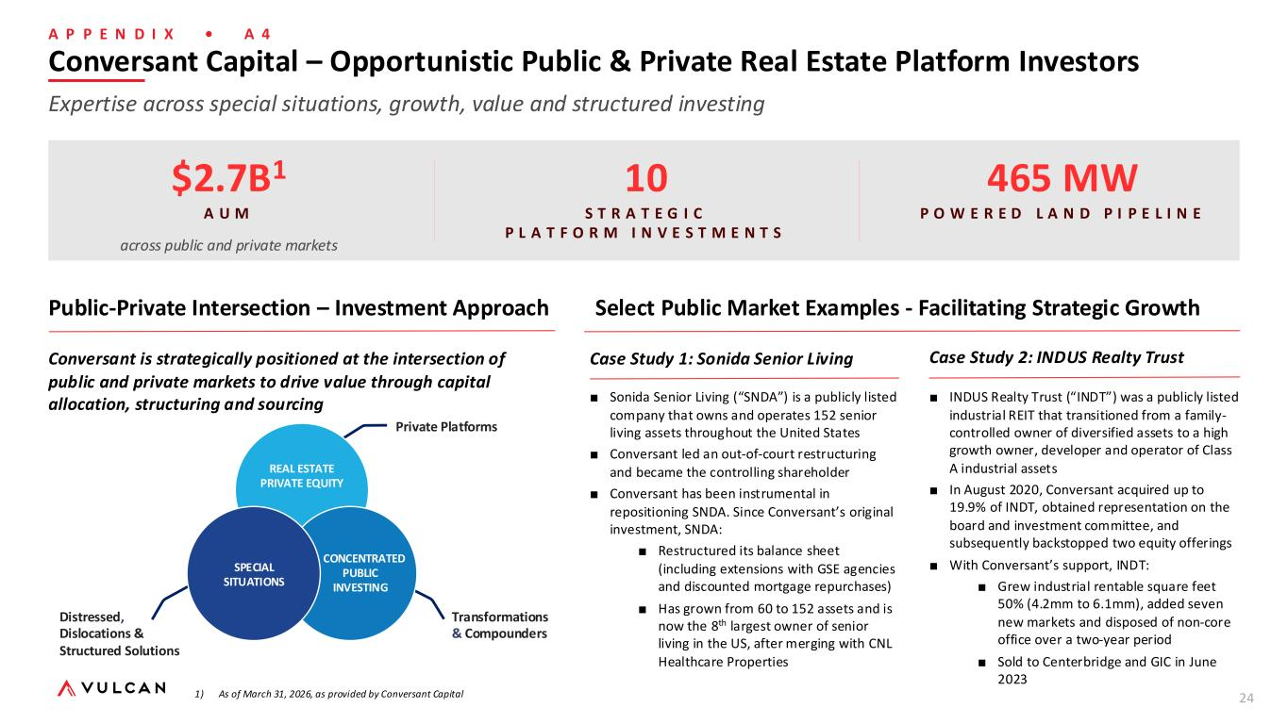
24 Conversant Capital – Opportunistic Public & Private Real Estate Platform Investors Expertise across special situations, growth, value and structured investing 1) As of March 31, 2026, as provided by Conversant Capital Public-Private Intersection – Investment Approach Select Public Market Examples - Facilitating Strategic Growth $2.7B1 A U M across public and private markets 10 S T R A T E G I C P L A T F O R M I N V E S T M E N T S 465 MW P O W E R E D L A N D P I P E L I N E Conversant is strategically positioned at the intersection of public and private markets to drive value through capital allocation, structuring and sourcing Case Study 1: Sonida Senior Living ■ Sonida Senior Living (“SNDA”) is a publicly listed company that owns and operates 152 senior living assets throughout the United States ■ Conversant led an out-of-court restructuring and became the controlling shareholder ■ Conversant has been instrumental in repositioning SNDA. Since Conversant’s original investment, SNDA: ■ Restructured its balance sheet (including extensions with GSE agencies and discounted mortgage repurchases) ■ Has grown from 60 to 152 assets and is now the 8th largest owner of senior living in the US, after merging with CNL Healthcare Properties Case Study 2: INDUS Realty Trust ■ INDUS Realty Trust (“INDT”) was a publicly listed industrial REIT that transitioned from a family- controlled owner of diversified assets to a high growth owner, developer and operator of Class A industrial assets ■ In August 2020, Conversant acquired up to 19.9% of INDT, obtained representation on the board and investment committee, and subsequently backstopped two equity offerings ■ With Conversant’s support, INDT: ■ Grew industrial rentable square feet 50% (4.2mm to 6.1mm), added seven new markets and disposed of non-core office over a two-year period ■ Sold to Centerbridge and GIC in June 2023 Transformations & Compounders Distressed, Dislocations & Structured Solutions Private Platforms A P P E N D I X • A 4 REAL ESTATE PRIVATE EQUITY SPECIAL SITUATIONS CONCENTRATED PUBLIC INVESTING

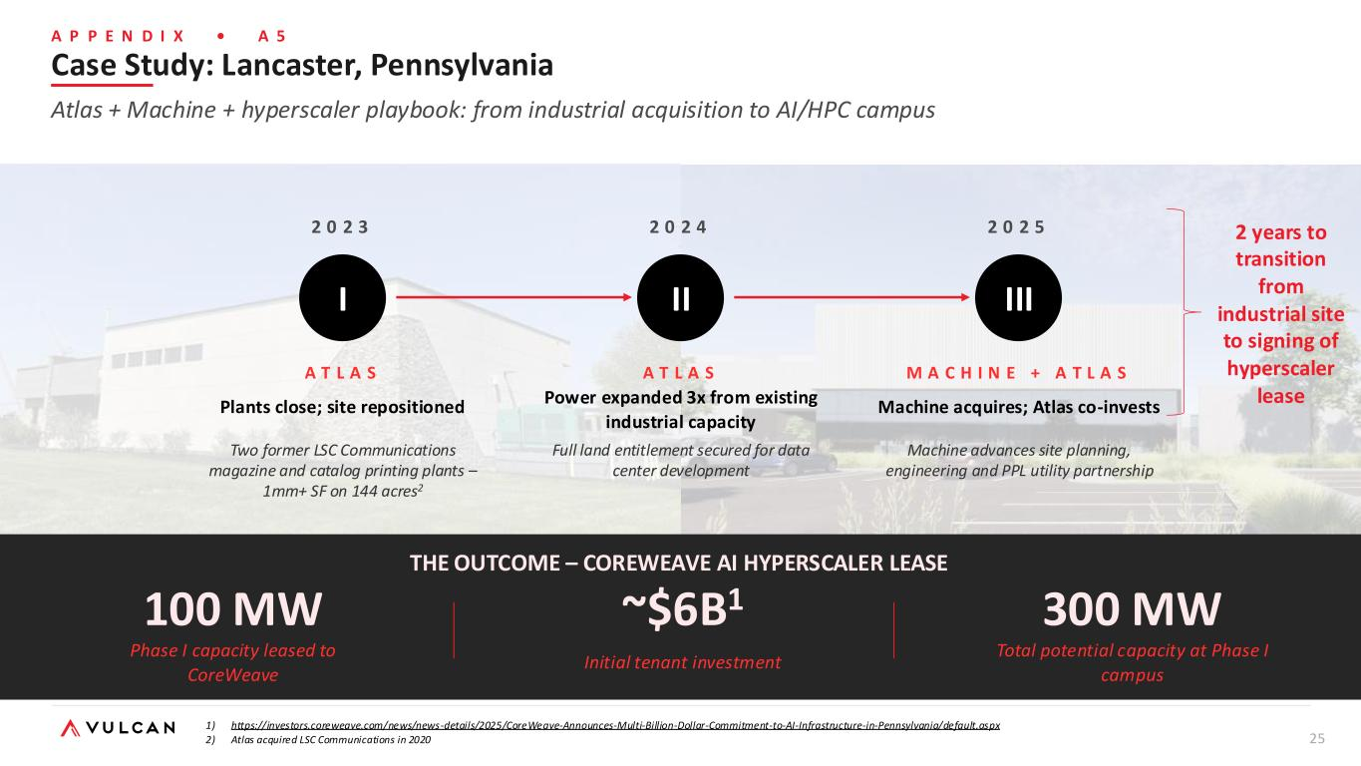
25 A P P E N D I X • A 5 2 0 2 3 I A T L A S Two former LSC Communications magazine and catalog printing plants – 1mm+ SF on 144 acres2 2 0 2 4 II A T L A S Full land entitlement secured for data center development 2 0 2 5 III M A C H I N E + A T L A S Machine advances site planning, engineering and PPL utility partnership THE OUTCOME – COREWEAVE AI HYPERSCALER LEASE 100 MW Phase I capacity leased to CoreWeave ~$6B1 Initial tenant investment 300 MW Total potential capacity at Phase I campus 2 years to transition from industrial site to signing of hyperscaler lease Case Study: Lancaster, Pennsylvania Atlas + Machine + hyperscaler playbook: from industrial acquisition to AI/HPC campus 1) https://investors.coreweave.com/news/news-details/2025/CoreWeave-Announces-Multi-Billion-Dollar-Commitment-to-AI-Infrastructure-in-Pennsylvania/default.aspx 2) Atlas acquired LSC Communications in 2020 Plants close; site repositioned Power expanded 3x from existing industrial capacity Machine acquires; Atlas co-invests

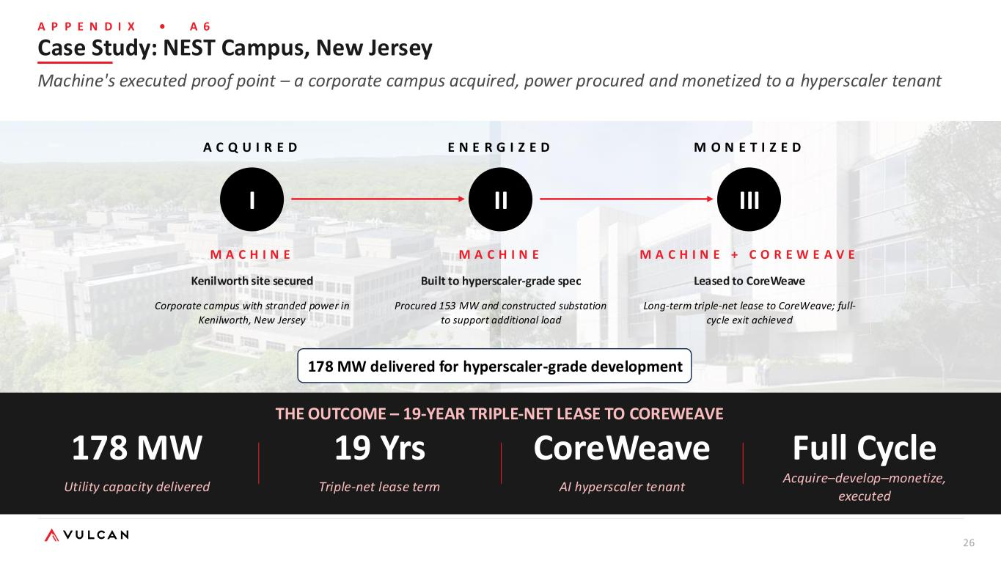
26 A C Q U I R E D I M A C H I N E Kenilworth site secured Corporate campus with stranded power in Kenilworth, New Jersey E N E R G I Z E D II M A C H I N E Built to hyperscaler-grade spec Procured 153 MW and constructed substation to support additional load M O N E T I Z E D III M A C H I N E + C O R E W E A V E Leased to CoreWeave Long-term triple-net lease to CoreWeave; full- cycle exit achieved THE OUTCOME – 19-YEAR TRIPLE-NET LEASE TO COREWEAVE 178 MW Utility capacity delivered 19 Yrs Triple-net lease term CoreWeave AI hyperscaler tenant Full Cycle Acquire–develop–monetize, executed 178 MW delivered for hyperscaler-grade development Case Study: NEST Campus, New Jersey Machine's executed proof point – a corporate campus acquired, power procured and monetized to a hyperscaler tenant A P P E N D I X • A 6

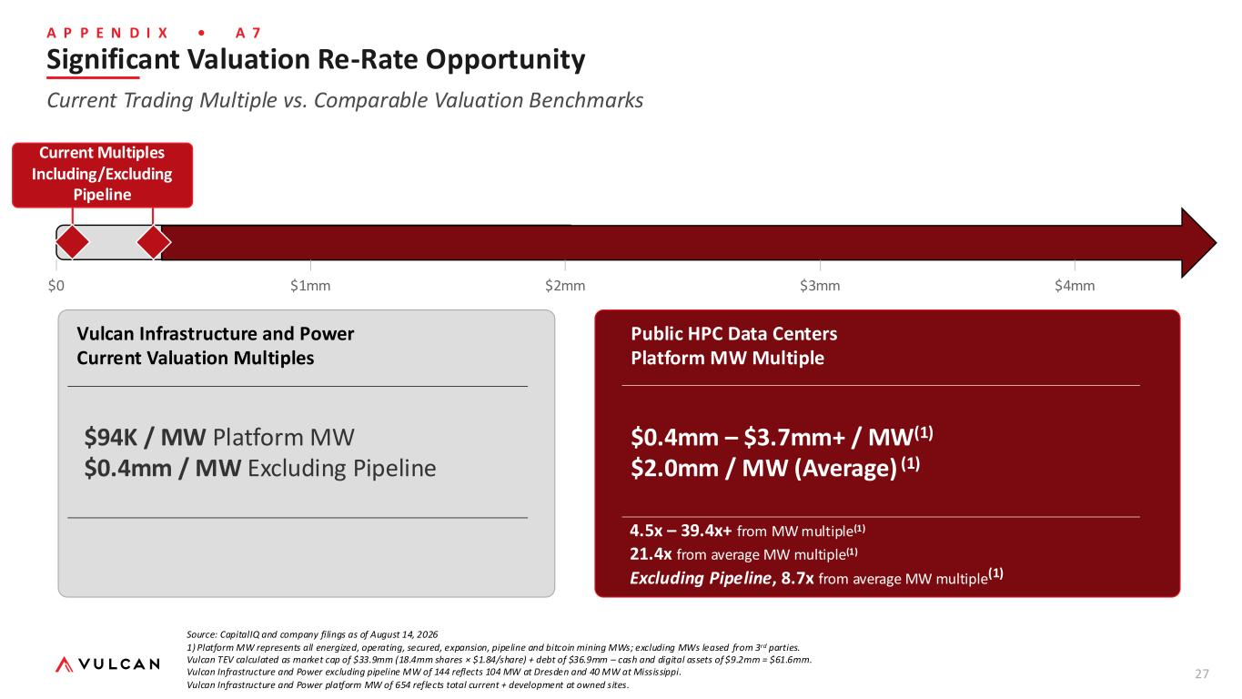
27 A P P E N D I X • A 7 $0 $1mm $2mm $3mm $4mm Vulcan Infrastructure and Power Current Valuation Multiples $94K / MW Platform MW $0.4mm / MW Excluding Pipeline Public HPC Data Centers Platform MW Multiple $0.4mm – $3.7mm+ / MW(1) $2.0mm / MW (Average) (1) Significant Valuation Re-Rate Opportunity Current Trading Multiple vs. Comparable Valuation Benchmarks Current Multiples Including/Excluding Pipeline Current Multiples Including/Excluding Pipeline 4.5x – 39.4x+ from MW multiple(1) 21.4x from average MW multiple(1) Excluding Pipeline, 8.7x from average MW multiple(1) Source: CapitalIQ and company filings as of August 14, 2026 1) Platform MW represents all energized, operating, secured, expansion, pipeline and bitcoin mining MWs; excluding MWs leased from 3rd parties. Vulcan TEV calculated as market cap of $33.9mm (18.4mm shares × $1.84/share) + debt of $36.9mm – cash and digital assets of $9.2mm = $61.6mm. Vulcan Infrastructure and Power excluding pipeline MW of 144 reflects 104 MW at Dresden and 40 MW at Mississippi. Vulcan Infrastructure and Power platform MW of 654 reflects total current + development at owned sites.

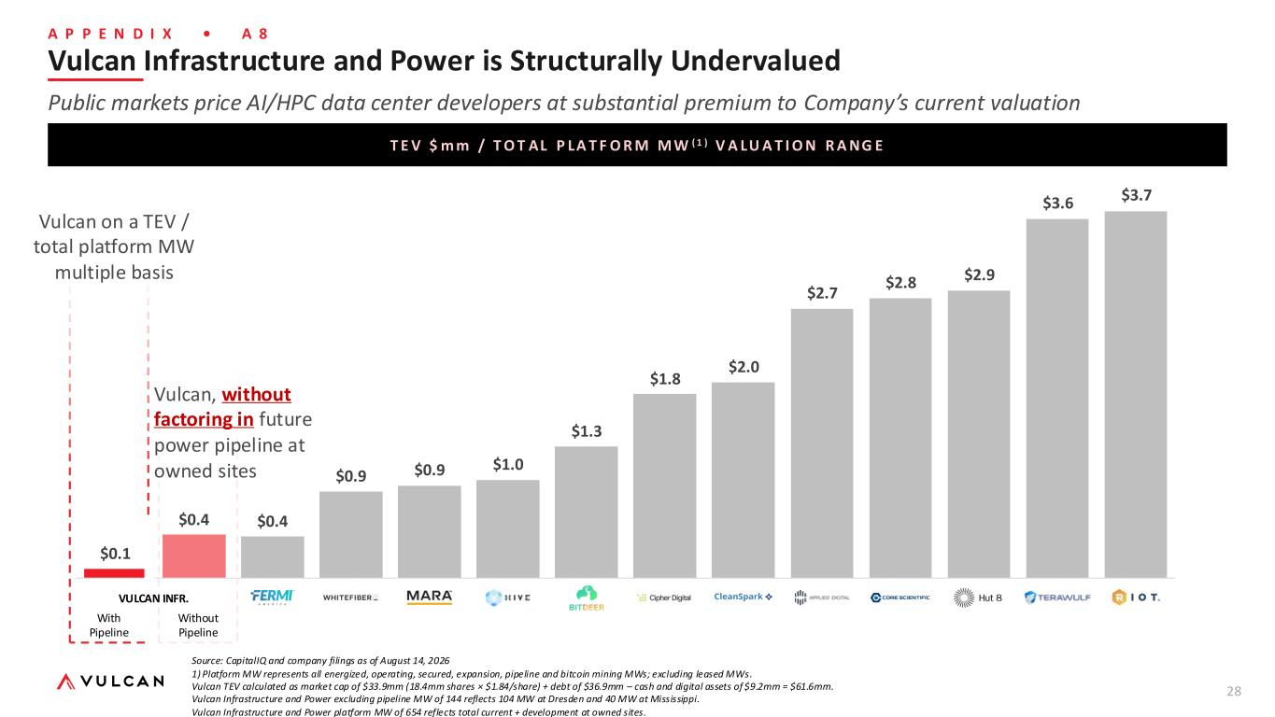
28 A P P E N D I X • A 8 T E V $ m m / T O T AL P LA T F O R M M W ( 1 ) V A LU A T I O N R A NG E Vulcan Infrastructure and Power is Structurally Undervalued Public markets price AI/HPC data center developers at substantial premium to Company’s current valuation Source: CapitalIQ and company filings as of August 14, 2026 1) Platform MW represents all energized, operating, secured, expansion, pipeline and bitcoin mining MWs; excluding leased MWs. Vulcan TEV calculated as market cap of $33.9mm (18.4mm shares × $1.84/share) + debt of $36.9mm – cash and digital assets of $9.2mm = $61.6mm. Vulcan Infrastructure and Power excluding pipeline MW of 144 reflects 104 MW at Dresden and 40 MW at Mississippi. Vulcan Infrastructure and Power platform MW of 654 reflects total current + development at owned sites. $3.7 $3.6 $2.9 $2.8 $2.7 $2.0 $1.8 $1.3 $1.0 $0.9 $0.9 $0.4 $0.4 $0.1 Without Pipeline With Pipeline Vulcan, without factoring in future power pipeline at owned sites Vulcan on a TEV / total platform MW multiple basis VULCAN INFR.

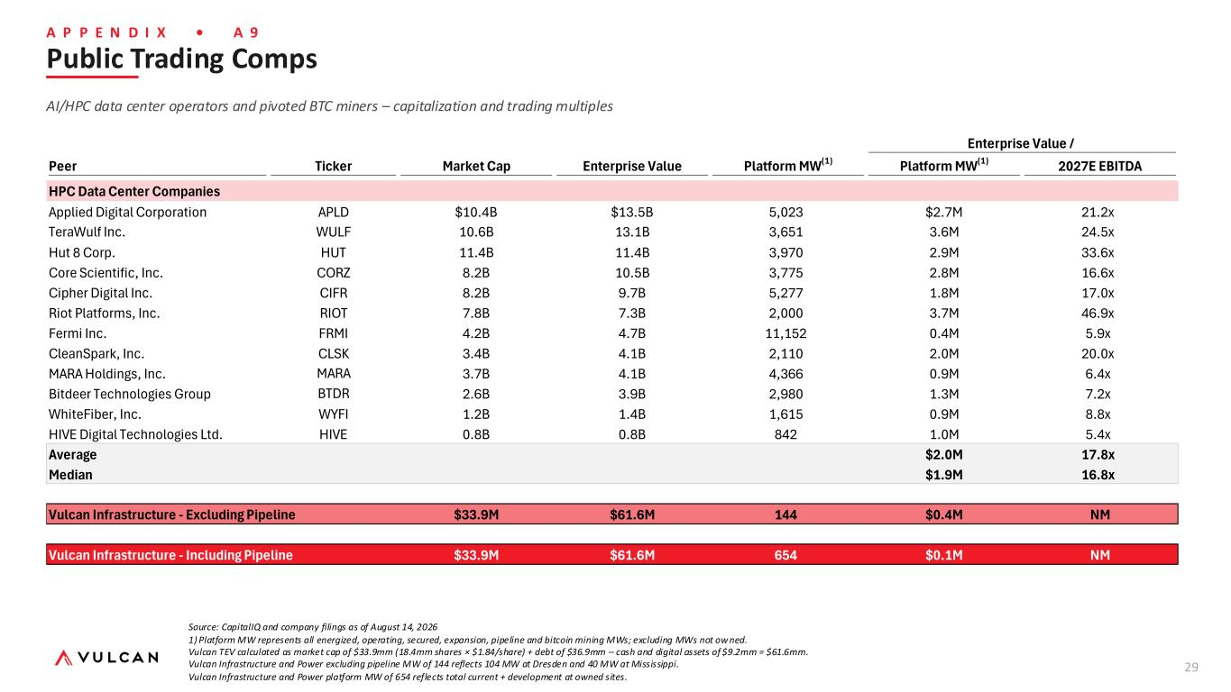
29 A P P E N D I X • A 9 Public Trading Comps AI/HPC data center operators and pivoted BTC miners – capitalization and trading multiples Source: CapitalIQ and company filings as of August 14, 2026 1) Platform MW represents all energized, operating, secured, expansion, pipeline and bitcoin mining MWs; excluding MWs not ow ned. Vulcan TEV calculated as market cap of $33.9mm (18.4mm shares × $1.84/share) + debt of $36.9mm – cash and digital assets of $9.2mm = $61.6mm. Vulcan Infrastructure and Power excluding pipeline MW of 144 reflects 104 MW at Dresden and 40 MW at Mississippi. Vulcan Infrastructure and Power platform MW of 654 reflects total current + development at owned sites. Enterprise Value / Peer Ticker Market Cap Enterprise Value Platform MW(1) Platform MW(1) 2027E EBITDA Vulcan Upside vs Select Comparables HPC Data Center Companies Applied Digital Corporation APLD $10.4B $13.5B 5,023 $2.7M 21.2x TeraWulf Inc. WULF 10.6B 13.1B 3,651 3.6M 24.5x Hut 8 Corp. HUT 11.4B 11.4B 3,970 2.9M 33.6x Core Scientific, Inc. CORZ 8.2B 10.5B 3,775 2.8M 16.6x Cipher Digital Inc. CIFR 8.2B 9.7B 5,277 1.8M 17.0x Riot Platforms, Inc. RIOT 7.8B 7.3B 2,000 3.7M 46.9x Fermi Inc. FRMI 4.2B 4.7B 11,152 0.4M 5.9x CleanSpark, Inc. CLSK 3.4B 4.1B 2,110 2.0M 20.0x MARA Holdings, Inc. MARA 3.7B 4.1B 4,366 0.9M 6.4x Bitdeer Technologies Group BTDR 2.6B 3.9B 2,980 1.3M 7.2x WhiteFiber, Inc. WYFI 1.2B 1.4B 1,615 0.9M 8.8x HIVE Digital Technologies Ltd. HIVE 0.8B 0.8B 842 1.0M 5.4x Average $2.0M 17.8x Median $1.9M 16.8x Vulcan Infrastructure - Excluding Pipeline $33.9M $61.6M 144 $0.4M NM Vulcan Infrastructure - Including Pipeline $33.9M $61.6M 654 $0.1M NM

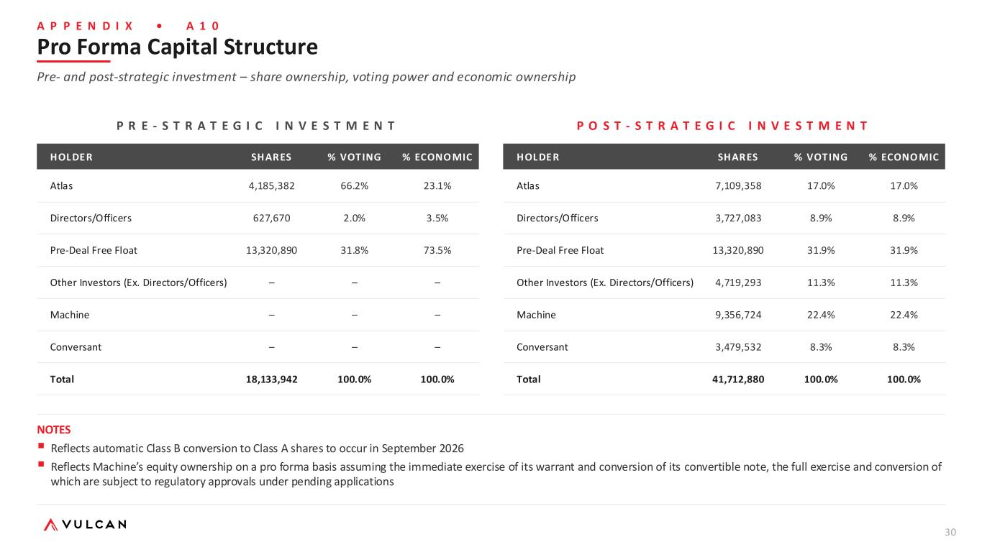
30 A P P E N D I X • A 1 0 Pro Forma Capital Structure Pre- and post-strategic investment – share ownership, voting power and economic ownership P R E - S T R A T E G I C I N V E S T M E N T HOLDER SHARES % VOTING % ECONO MIC Atlas 4,185,382 66.2% 23.1% Directors/Officers 627,670 2.0% 3.5% Pre-Deal Free Float 13,320,890 31.8% 73.5% Other Investors (Ex. Directors/Officers) – – – Machine – – – Conversant – – – Total 18,133,942 100.0% 100.0% P O S T - S T R A T E G I C I N V E S T M E N T HOLDER SHARES % VOTING % ECONO MIC Atlas 7,109,358 17.0% 17.0% Directors/Officers 3,727,083 8.9% 8.9% Pre-Deal Free Float 13,320,890 31.9% 31.9% Other Investors (Ex. Directors/Officers) 4,719,293 11.3% 11.3% Machine 9,356,724 22.4% 22.4% Conversant 3,479,532 8.3% 8.3% Total 41,712,880 100.0% 100.0% NOTES ▪ Reflects automatic Class B conversion to Class A shares to occur in September 2026 ▪ Reflects Machine’s equity ownership on a pro forma basis assuming the immediate exercise of its warrant and conversion of its convertible note, the full exercise and conversion of which are subject to regulatory approvals under pending applications

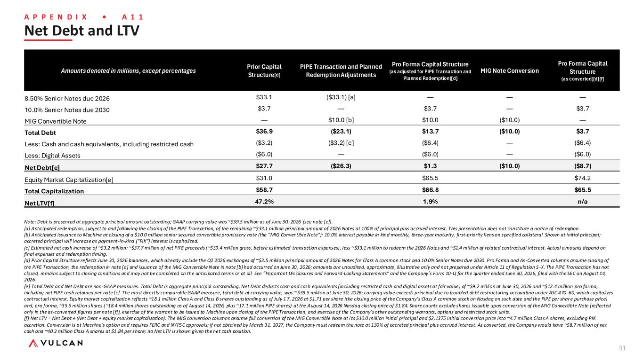
31 A P P E N D I X • A 1 1 Net Debt and LTV Note: Debt is presented at aggregate principal amount outstanding; GAAP carrying value was ~$39.5 million as of June 30, 2026 (see note [e]). [a] Anticipated redemption, subject to and following the closing of the PIPE Transaction, of the remaining ~$33.1 million pri ncipal amount of 2026 Notes at 100% of principal plus accrued interest. This presentation does not constitute a notice of redemption. [b] Anticipated issuance to Machine at closing of a $10.0 million senior secured convertible promissory note (the “MIG Conver tible Note”): 10.0% interest payable in kind monthly, three-year maturity, first-priority liens on specified collateral. Shown at initial principal; accreted principal will increase as payment-in-kind (“PIK”) interest is capitalized. [c] Estimated net cash increase of ~$3.2 million: ~$37.7 million of net PIPE proceeds (~$39.4 million gross, before estimated transaction expenses), less ~$33.1 million to redeem the 2026 Notes and ~$1.4 million of related contractual interest. Actual a mounts depend on final expenses and redemption timing. [d] Prior Capital Structure reflects June 30, 2026 balances, which already include the Q2 2026 exchanges of ~$3.5 million pri ncipal amount of 2026 Notes for Class A common stock and 10.0% Senior Notes due 2030. Pro Forma and As -Converted columns assume closing of the PIPE Transaction, the redemption in note [a] and issuance of the MIG Convertible Note in note [b] had occurred on June 30 , 2026; amounts are unaudited, approximate, illustrative only and not prepared under Article 11 of Regulation S -X. The PIPE Transaction has not closed, remains subject to closing conditions and may not be completed on the anticipated terms or at all. See “Important Dis closures and Forward-Looking Statements” and the Company’s Form 10-Q for the quarter ended June 30, 2026, filed with the SEC on August 14, 2026. [e] Total Debt and Net Debt are non-GAAP measures. Total Debt is aggregate principal outstanding; Net Debt deducts cash and cash equivalents (including restricted cash and digital assets at fair value) of ~$9.2 million at June 30, 2026 and ~$12.4 million pro forma, including net PIPE cash retained per note [c]. The most directly comparable GAAP measure, total debt at carrying value, was ~ $39.5 million at June 30, 2026; carrying value exceeds principal due to troubled debt restructuring accounting under ASC 470 -60, which capitalizes contractual interest. Equity market capitalization reflects ~18.1 million Class A and Class B shares outstanding as of July 1 7, 2026 at $1.71 per share (the closing price of the Company’s Class A common stock on Nasdaq on such date and the PIPE per share purchase price) and, pro forma, ~35.6 million shares (~18.4 million shares outstanding as of August 14, 2026, plus ~17.1 million PIPE shares) at the August 14, 2026 Nasdaq closing price of $1.84. Share counts exclude shares issuable upon conversion of the MIG Convertible Note (reflected only in the as-converted figures per note [f]), exercise of the warrant to be issued to Machine upon closing of the PIPE Transac tion, and exercise of the Company’s other outstanding warrants, options and restricted stock units. [f] Net LTV = Net Debt ÷ (Net Debt + equity market capitalization). The MIG conversion columns assume full conversion of the MIG Convertible Note at i ts $10.0 million initial principal and $2.1375 initial conversion price into ~4.7 million Class A shares, excluding PIK accretion. Conversion is at Machine’s option and requires FERC and NYPSC approvals; if not obtained by March 31, 2027, the Company must redeem the note at 130% of accreted principal plus accrued interest. As converted, the Company would have ~$8.7 million of net cash and ~40.3 million Class A shares at $1.84 per share; no Net LTV is shown given the net cash position. Amounts denoted in millions, except percentages Prior Capital Structure[d] PIPE Transaction and Planned Redemption Adjustments Pro Forma Capital Structure (as adjusted for PIPE Transaction and Planned Redemption)[d] MIG Note Conversion Pro Forma Capital Structure (as converted)[d][f] 8.50% Senior Notes due 2026 $33.1 ($33.1) [a] — — — 10.0% Senior Notes due 2030 $3.7 — $3.7 — $3.7 MIG Convertible Note — $10.0 [b] $10.0 ($10.0) — Total Debt $36.9 ($23.1) $13.7 ($10.0) $3.7 Less: Cash and cash equivalents, including restricted cash ($3.2) ($3.2) [c] ($6.4) — ($6.4) Less: Digital Assets ($6.0) — ($6.0) — ($6.0) Net Debt[e] $27.7 ($26.3) $1.3 ($10.0) ($8.7) Equity Market Capitalization[e] $31.0 $65.5 $74.2 Total Capitalization $58.7 $66.8 $65.5 Net LTV[f] 47.2% 1.9% n/a


Vulcan Infrastructure and Power Publishes Investor Presentation Highlighting its Pivot to a New Growth Platform
Presentation Provides Additional Detail on Previously Announced $39.4 Million Capital Raise and Vulcan’s AI/HPC Infrastructure Strategy
PITTSFORD, N.Y.—August 17, 2026-- Vulcan Infrastructure and Power Inc. (Nasdaq: VIP) (“Vulcan” or the “Company”) today announced the publication of a new investor presentation providing an overview of the Company’s previously announced financing transaction (the “PIPE transaction”) and its strategy to build a differentiated power and infrastructure platform serving artificial intelligence and high-performance computing (“AI/HPC”) data centers.
The presentation provides additional detail regarding Vulcan’s asset base and its development pipeline, the strategic capabilities of the Company, the anticipated impact of the PIPE transaction on Vulcan’s capital structure, and the Company’s strategy for sourcing, developing and monetizing powered infrastructure assets.
Beginning today, Vulcan will use the presentation as part of its investor outreach, including meetings and discussions with institutional investors, sell-side research analysts and other members of the investment community. The Company intends to maintain an active investor engagement program as it executes its strategy and advances the development of its power and infrastructure platform.

The presentation highlights:

•A 654 MW combined pipeline at Vulcan-owned sites, including more than 100 MW of capacity expected to be available for AI/HPC opportunities within the next year;

•The anticipated strengthening of Vulcan’s balance sheet following the proposed PIPE transaction and planned redemption of the Senior Notes due October 2026 (the "Senior Notes"); and

•The expected sourcing, development and operating capabilities of Vulcan and its strategic investors, including Atlas Holdings,[1] Machine Investment Group and Conversant Capital.

“We believe the presentation provides investors with a more comprehensive view of the assets, capabilities and opportunity that underpin the next phase of Vulcan’s development,” said Jordan Kovler, Chief Executive Officer of Vulcan Infrastructure and Power.

“The previously financing announced transaction is intended to strengthen our balance sheet and bring together an experienced group of strategic investors with deep expertise across power, industrial real estate and digital infrastructure. With significant existing and prospective power capacity, we believe Vulcan has a compelling opportunity to build a differentiated AI infrastructure platform.”

The investor presentation has been furnished with the Securities and Exchange Commission on Form 8-K and is also available at the Company’s website at www.vulcanip.com.

The previously announced PIPE transaction has not closed, remains subject to customary closing conditions and may not be completed on the anticipated terms or at all.

No Offer to Sell or Solicit

This press release is for informational purposes only and does not constitute an offer to sell or the solicitation of an offer to buy any of the securities described herein, nor shall there be any sale of these securities in any state or jurisdiction in which such offer, solicitation or sale would be unlawful prior to the registration or qualification under the securities laws of any such state or jurisdiction.

No Notice of Redemption

This press release does not constitute a notice of redemption with respect to the Company's outstanding Senior Notes under the indenture and supplemental indenture governing the Senior Notes and does not create any obligation on the part of the Company to redeem any of the Senior Notes or to issue any notice of redemption. Any redemption of the Senior Notes, if effected, will be made only in accordance with, and subject to the terms and conditions of, the indenture and supplemental indenture governing the Senior Notes, including the applicable notice requirements and satisfaction of any conditions precedent to such redemption.

Forward-Looking Statements

This press release includes certain statements that may constitute “forward-looking statements” within the meaning of Section 27A of the Securities Act of 1933, as amended, and Section 21E of the Exchange Act. All statements other than statements of historical fact are forward-looking statements for purposes of federal and state securities laws. These forward-looking statements involve uncertainties that could significantly affect Vulcan’s financial or operating results. These forward-looking statements may be identified by terms such as “anticipate,” “believe,” “continue,” “foresee,” “expect,” “intend,” “plan,” “may,” “will,” “would,” “could,” and “should,” and the negative of these terms or other similar expressions. Forward-looking statements are based on current beliefs and assumptions that are subject to risks and uncertainties and are not guarantees of future performance. Forward-looking statements in this press release include, among other things, statements regarding the AI/HPC transition, the proposed transaction described herein, including the proposed timing and steps contemplated in respect of the proposed transaction and approvals with respect thereto, the use of proceeds from the proposed transaction, and the business plan, business strategy and operations of Vulcan in the future. In addition, all statements that address operating performance and future performance, events or developments that are expected or anticipated to occur in the future are forward-looking statements. Forward-looking statements are subject to a number of risks, uncertainties and assumptions. Matters and factors that could cause actual results to differ materially from those expressed or implied in such forward-looking statements include but are not limited to the matters and factors described in Part I, Item 1A. “Risk Factors” of Vulcan’s Annual Report on Form 10-K for the year ended December 31, 2025, as may be amended from time to time, its subsequently filed Quarterly Reports on Form 10-Q and its other filings with the SEC. Consequently, all of the forward-looking statements made in this press release are qualified by the

information contained under this caption. No assurance can be given that these are all of the factors that could cause actual results to vary materially from the forward-looking statements in this press release. You should not put undue reliance on forward-looking statements. No assurances can be given that any of the events anticipated by the forward-looking statements will transpire or occur, or if any of them do occur, the actual results, performance, or achievements of Vulcan could differ materially from the results expressed in, or implied by, any forward-looking statements. All forward-looking statements speak only as of the date of this press release and, unless otherwise required by U.S. federal securities laws, Vulcan does not assume any duty to update or revise any forward-looking statements included in this press release, whether as a result of new information, the occurrence of future events, uncertainties or otherwise, after the date of this press release.
[1] Atlas FRM LLC d/b/a Atlas Holdings LLC is an investment advisor to affiliated private funds.
Investor Contact
FNK IR
Rob Fink or Joey Delahoussaye
ir@vulcanip.com
312-809-1087

